AquaCropPlotter

Reference Manual

Table of Contents

1. About AquaCropPlotter 4

2. Access and installation 4

2.1 Online web application 4

2.2 Local installation on user's own computer 4

3. Overview of interface 5

3.1 The app interface 5

3.2 Interacting with the app 5

3.2.1 Selection (single): 5

3.2.2 Selection (multiple): 5

3.3.3 Action button: 6

3.3.4 Free text: 6

3.3.5 Slider: 6

4. Overview of workflow 6

4.1 Upload data 6

4.2 Combined data 6

4.3 Plot 7

4.4 Analysis 7

5. Upload data 7

5.1 File naming convention 7

5.1.1 File name prefix 7

5.1.2 Name variable extraction 7

5.2 AquaCrop programme output specification 8

5.3 Browse and upload files 8

5.3.1 GUI data upload 8

5.3.2 Plug-in data upload 9

6. Combined data 10

6.1 Combined data tables 10

6.1.1 Project files 10

6.1.2 Seasonal dataset 10

6..1.3 Daily dataset 11

6.2 Rename column 11

6.3 Filter dataset 11

6.4 Advanced data labeling 12

6.4.1 Add custom labels by year range 12

7. Plot 12

7.1 Scatter plot/ Trend/ Time series 12

7.1.1 Select plotting variables 12

7.1.2 Select grouping variables 14

7.1.3 Summary statistics 14

7.1.4 Customise and export plot 15

7.2 Boxplot 17

7.2.1 Select plotting variables 17

7.2.2 Select grouping variables 18

7.2.3 Plot values relative to an average from reference period 19

7.2.4 Customise and export plot 20

8. Analysis 22

8.1 Time window summary 22

8.2 Regression 22

9. Case Study 23

9.1 AquaCrop GUI 23

9.1.1 Upload data 23

9.1.2 Combined data 23

9.1.3 Plot 24

9.2 AquaCrop Plug-in 25

9.2.1 Upload data 26

9.2.2 Combined data 26

9.2.3 Plot 28

9.2.4 Analysis 36

# 1. About AquaCropPlotter

AquaCropPlotter is a tool designed to facilitate the analysis and visualisation of data from AquaCrop (version 6 and 7), the crop-water productivity model developed by FAO. AquaCropPlotter provides a simple interface for users to upload and process output data files from AquaCrop simulations to generate meaningful plots and simple statistical analysis. This tool aims to streamline data processing to allow users to gain insight into complex data without requiring computing background.

AquaCropPlotter is developed and maintained by Nattapong Sanguankiattichai and Riccardo Soldan, with contributions from the AquaCrop developer team and support from The Office of Climate Change, Biodiversity and Environment (OCB) and the Land and Water Division (NSL) of The Food and Agriculture Organization (FAO).

For more information or issue reporting, visit our AquaCropPlotter Github page at <https://github.com/Risk-Team/AquaCropPlotter/>

# 2. Access and installation

AquaCropPlotter can be used in two ways: online web application or local installation on user's own computer. Both ways provide the same interface and functionality. The online web application requires internet connection and might be slightly slower than local installation as data have to be transferred through the internet. For local installation, there are two options: a standalone app (for Windows only) or an R package (all operating systems).

2.1 Online web application

This is freely available and can be accessed through web browser at <https://foodandagricultureorganization.shinyapps.io/AquaCropPlotter/>

2.2 Local installation on user's own computer

### 2.2.1 Standalone app (for Windows only)

Download an installer (AquaCropPlotter_installer.exe) from the latest release at <https://github.com/Risk-Team/AquaCropPlotter/releases>

### 2.2.2 R package

This option requires user to have R software (https://www.r-project.org/) and install AquaCropPlotter as a package. The source code is available at <https://github.com/Risk-Team/AquaCropPlotter/>

To install AquaCropPlotter in R

install.packages("devtools")

library(devtools)

install_github("Risk-Team/AquaCropPlotter/AquaCropPlotter")

To launch AquaCropPlotter after installation

library(AquaCropPlotter)

aquacropplotter()

# 3. Overview of interface

## 3.1 The app interface

The app starts at launch with the Home page, which shows the workflow summary diagram. The main sidebar on the left of the window contains menu options for navigating through different parts of the app.

- **Home** - the home page

- **Workflow** - a menu for navigating through different steps of the app workflow

- **Glossary** - a searchable list of terms used in AquaCrop data together with their definition and unit.

- **Help** - instructions and reference manual for the use of the app

- **About** - information about the app

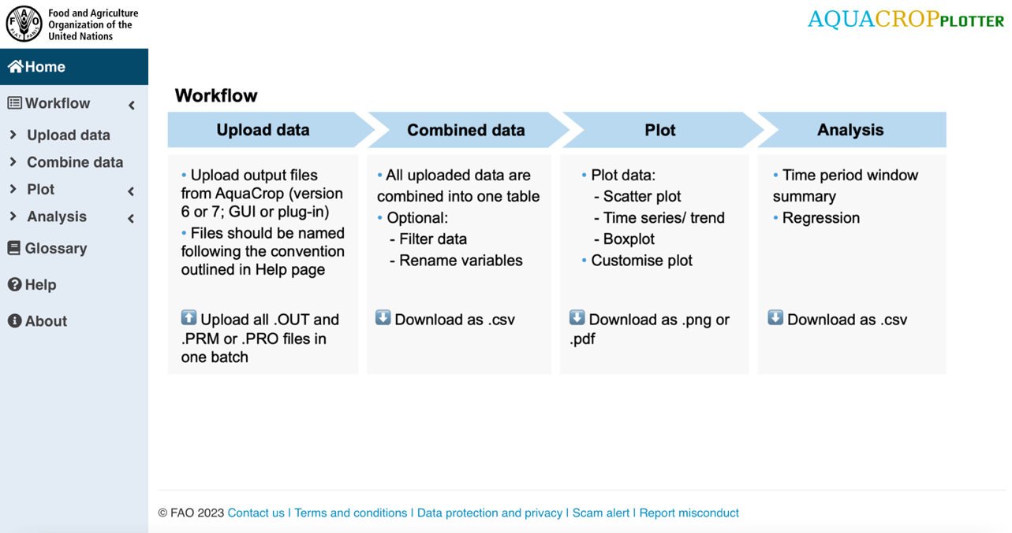

## 3.2 Interacting with the app

The app takes several types of input from the user as illustrated by the following examples.

3.2.1 Selection (single): User can click the box to show available options. Only one option can be chosen. To change the selected options, simply click and select a new option. To remove selected options, click on it and press backspace key on the keyboard. To search for an option, type in the box and it will search for an option that matches the text as typed in.

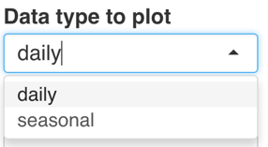

3.2.2 Selection (multiple): User can click the box to show available options. Multiple options can be chosen by clicking each one. All currently selected options appear in the box. To remove selected options, click on it and press backspace key on the keyboard. Options are added in the order they are selected. To search for an option, type in the box and it will search for an option that matches the text as typed in.

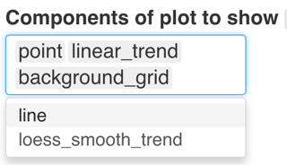

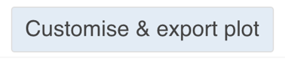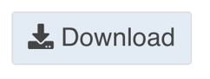3.3.3 Action button: User can click the button to execute the specified action. Some buttons that display other windows when clicked can be reversed by clicking again.

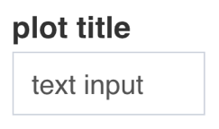3.3.4 Free text: User can type text input directly into the box.

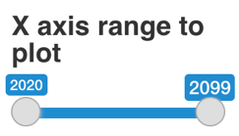3.3.5 Slider:User can select a range of numerical values by sliding the slider to specify the minimum (left) and maximum (right) value.

# 4. Overview of workflow

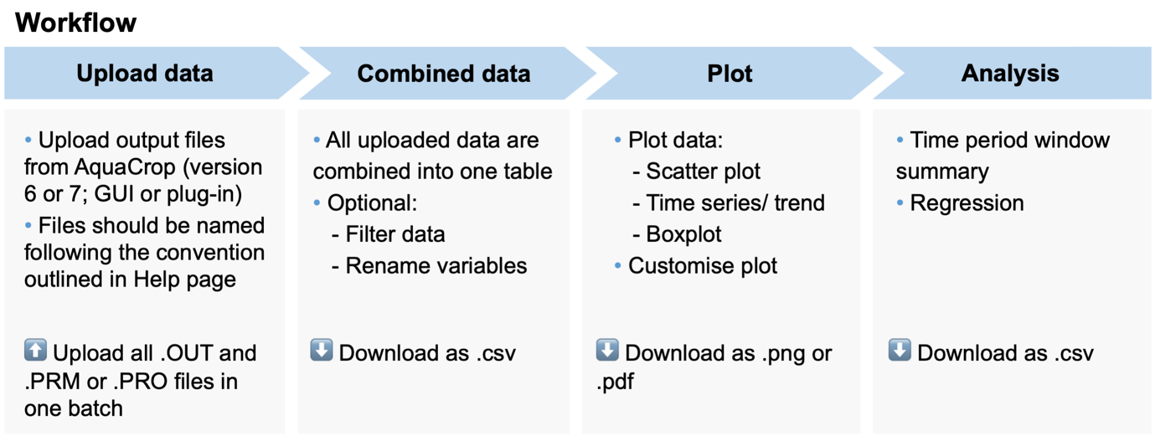

AquaCropPlotter workflow consists of 4 main steps:

## 4.1 Upload data

Users upload all output files from AquaCrop simulation as an input into AquaCropPlotter in one batch. The file names should follow the naming convention of the app to allow automated processing of names to extract information to be used for later steps.

## 4.2 Combined data

AquaCropPlotter automatically processes and combines all data that are uploaded into a single data table for each type of dataset (daily, seasonal, project files). This combined data table is used by the app for the subsequent plot and analysis steps. Data can be filtered, or variables renamed to suit particular analysis. The combined data can be exported as .csv so users can keep the record or easily process the formatted data in other software.

## 4.3 Plot

AquaCropPlotter provides a flexible plotting tool to visualise the data. Users can plot the data in scatter plots, trend or time series, and boxplots. The plot can also be highly customised by the user. The final plots can be exported as .pdf or .png files to be used in reports.

## 4.4 Analysis

AquaCropPlotter offers simple statistical analysis options including time window summary and regression. The results are displayed in table which can be exported as .csv file.

# 5. Upload data

## 5.1 File naming convention

AquaCropPlotter facilitates the analysis of outputs from multiple AquaCrop simulations by automatically processing all user-uploaded files at once. To allow the app to do this, some file naming conventions should be followed.

5.1.1 File name prefix Output data files (.OUT) and project files (.PRO or .PRM) of each simulation are recognised automatically by matching the name prefixes, so make sure all file names from one simulation have the same prefix (This should already be the default for output from AquaCrop).

For example, if a simulation from AquaCrop plug-in is to be named simulation1, the prefix is simulation1 and the resulting file names should be simulation1PRMday.OUT, simulation1PRMseason.OUT and simulation1.PRM

5.1.2 Name variable extraction Variables from file name prefixes are automatically extracted when they are separated by underscores ( _ ). This allows users to supply variables or information associated with each simulation that can be used for plotting and analysis of the data inside the app. When these data are imported into the app, detected variables are added to the dataset as new columns, designated by 'name.variable' followed by a number in the order that they are detected from the file name prefix.

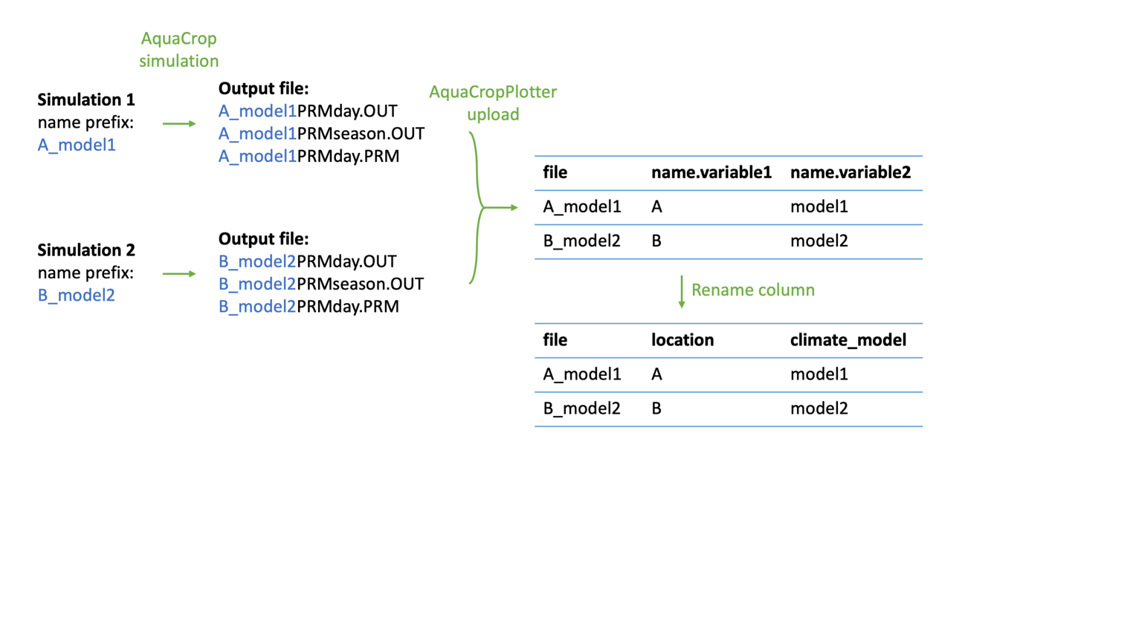For example, if 2 AquaCrop simulations were run for two different locations (A and B) using two different climate models (model1 and model2) respectively, file name prefixes could be A_model1 and B_model2. Once uploaded, the first variable, location, will be extracted into name.variable1 and the second variable, climate model, will be extracted into name.variable2. These automatically generated name.variable columns can be renamed (in Combined data step) by the user to reflect the values they contain, as illustrated below.

## 5.2 AquaCrop programme output specification

AquaCropPlotter is designed to process output files from AquaCrop version 6 and 7, both GUI and plug-in. The type of AquaCrop programme used to generate the data to be should be specified by selecting the option from the menu at the top of the Upload data page.

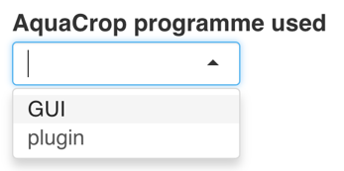

## 5.3 Browse and upload files

Once the type of AquaCrop programme used is chosen, a new box will appear for browsing and uploading corresponding data files.

### 5.3.1 GUI data upload

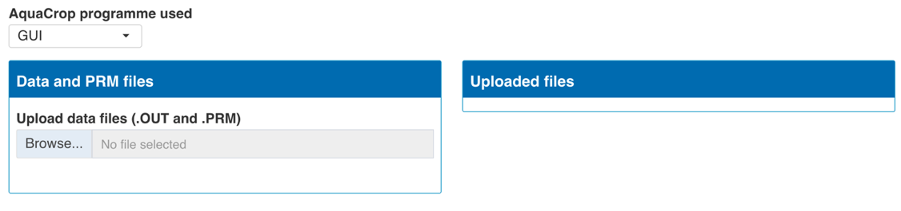

Click browse to select files to upload from your computer. All files should be put in one folder and uploaded in one batch (highlight all files in the file selection window to upload altogether). There are 10 output files from AquaCrop to upload for each simulation, including .PRM, Clim.OUT, CompEC.OUT, CompWC.OUT, Crop.OUT, Inet.OUT, Prof.OUT, Run.OUT, Salt.OUT and Wabal.OUT. For example:

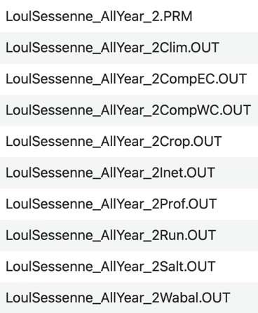

Results from multiple simulations can also be uploaded together for analysis or comparison. For example, if two simulations are to be analysed, 20 output files (10 from each simulation) should be uploaded together.

Once the upload is complete, the app will show a list of data files that were uploaded.

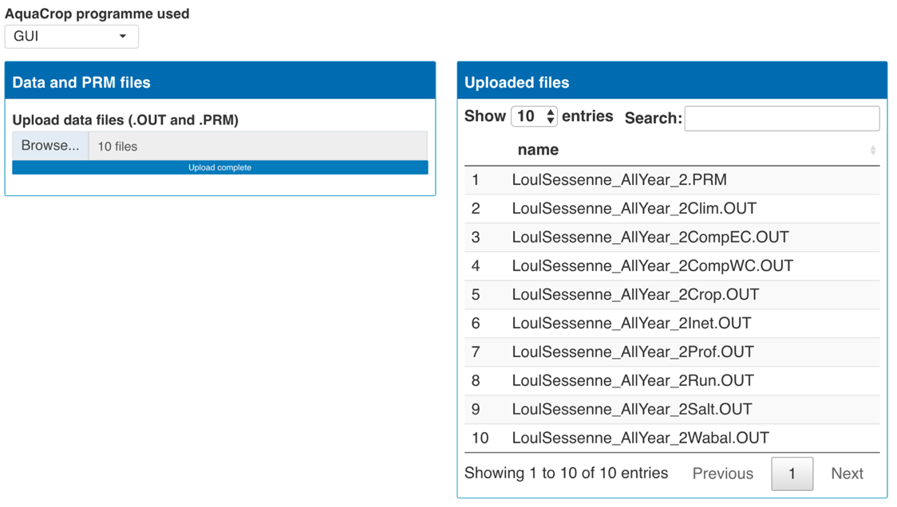

### 5.3.2 Plug-in data upload

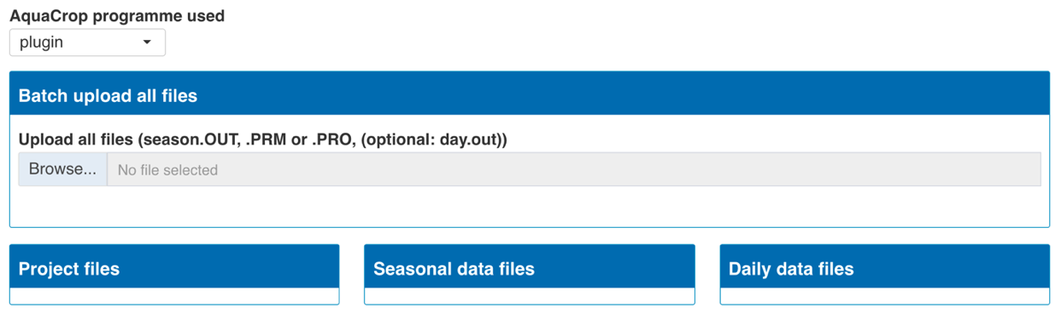

Click browse to select files to upload from your computer. All files should be put in one folder and uploaded in one batch (highlight all files in the file selection window to upload altogether). There are 3 output files from AquaCrop to upload for each simulation: .PRM or .PRO, day.OUT and season.OUT. Outputs from multiple simulations can be uploaded in one batch so the total number of files can be larger. For example:

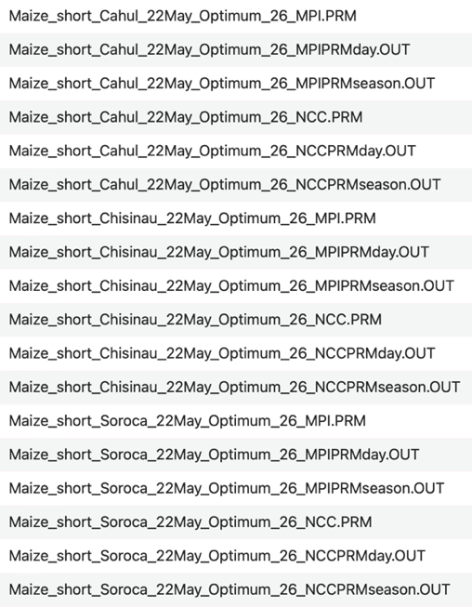

Once the upload is complete, the app will show lists of data files that were uploaded, by type (project files, daily or seasonal data). If files were named according to the naming convention, the number of variables automatically recognised from the file names are displayed.

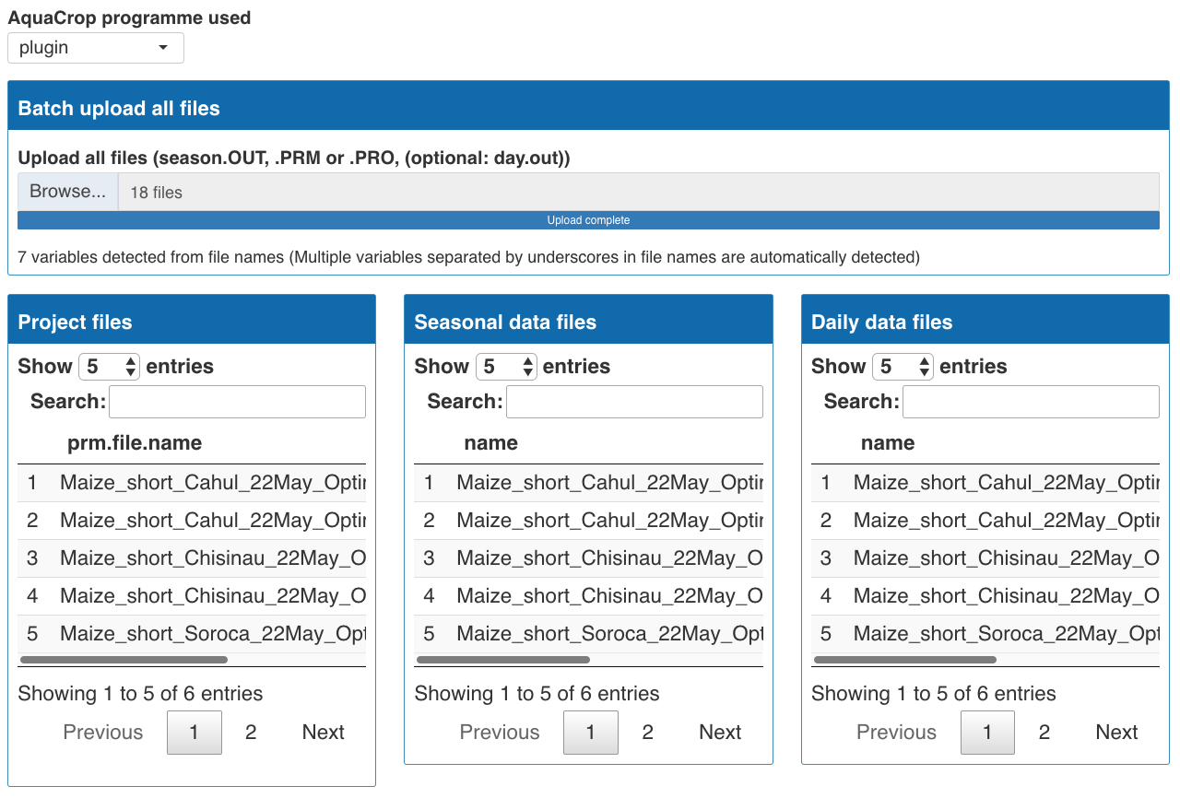

Since daily data (day.OUT) file size can be large and slow down the upload, it can be omitted if it is not intended to be visualised or analysed.

# 6. Combined data

## 6.1 Combined data tables

Once all files are uploaded, all data are processed and combined into one table for each of the type of data files: project files (.PRO or .PRM), daily data and seasonal data, which can be navigated through the tabs on the top of the page and scrollable. These combined datasets can also be downloaded by clicking the download button above each table.

### 6.1.1 Project files

All project files and parameters that are used to run AquaCrop simulations are automatically extracted into columns. Additionally, name variables are also extracted from file names, as per the naming convention explained in section 5.1.

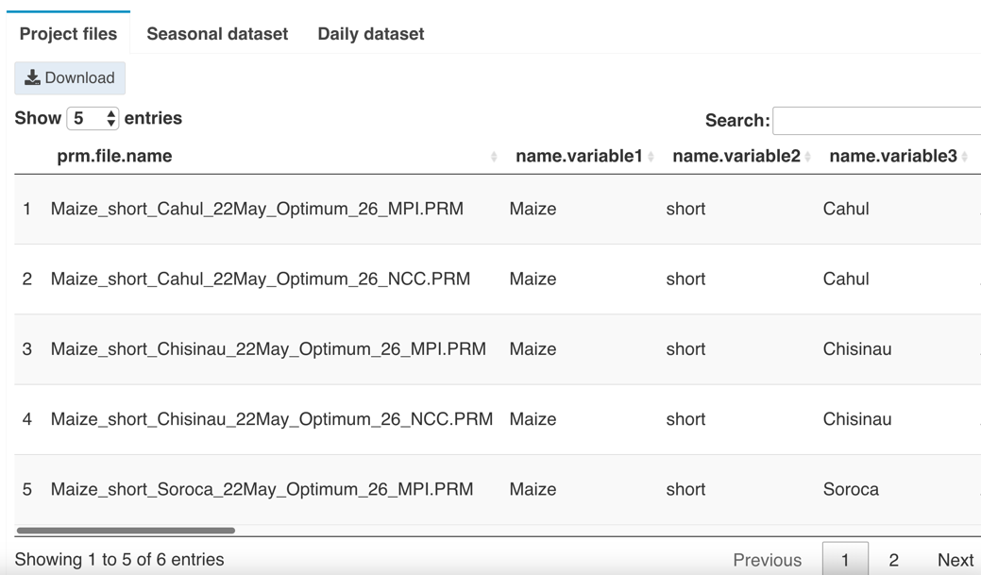

### 6.1.2 Seasonal dataset

Seasonal data from all simulations are combined into a single table. Additionally, file names are extracted and matched to the parameters and name variable information provided by the project files so each data point is associated with the corresponding information.

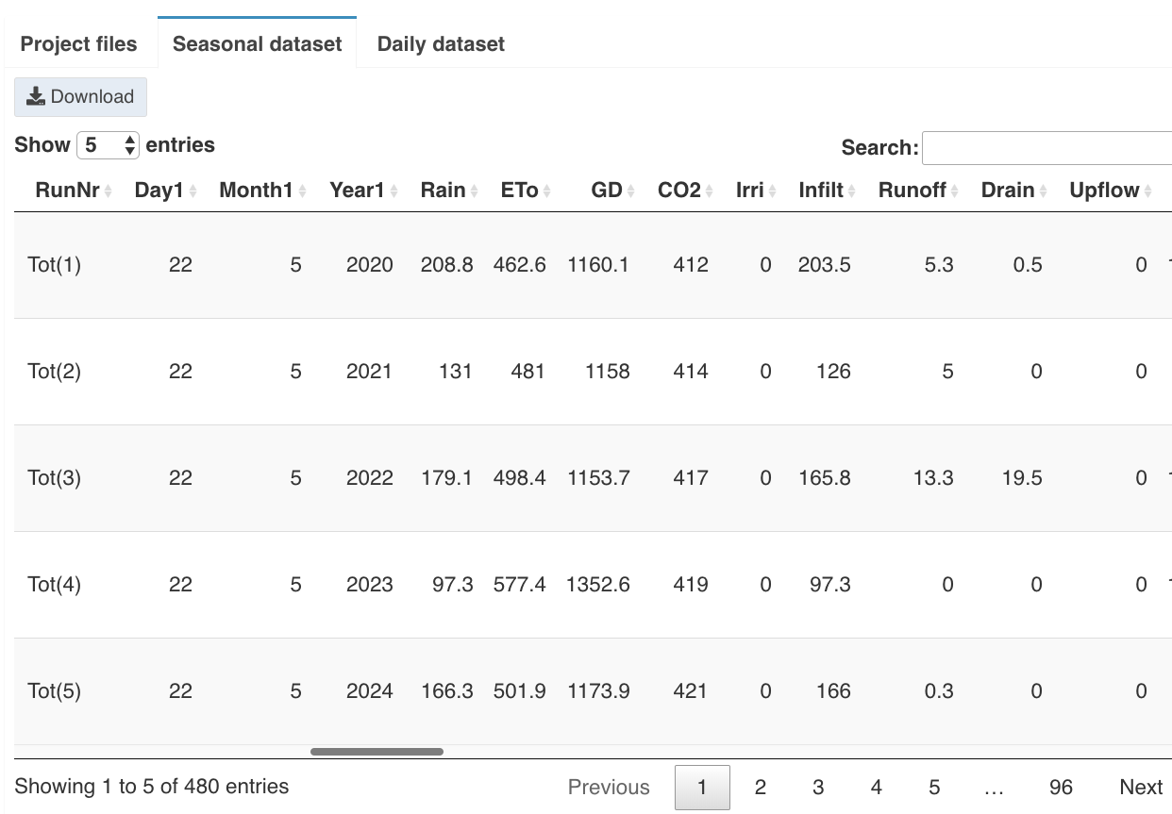

### 6..1.3 Daily dataset

Daily data from all simulations are combined into a single table. Additionally, file names are extracted and matched to the parameters and name variable information provided by the project files so each data point is associated with the corresponding information.

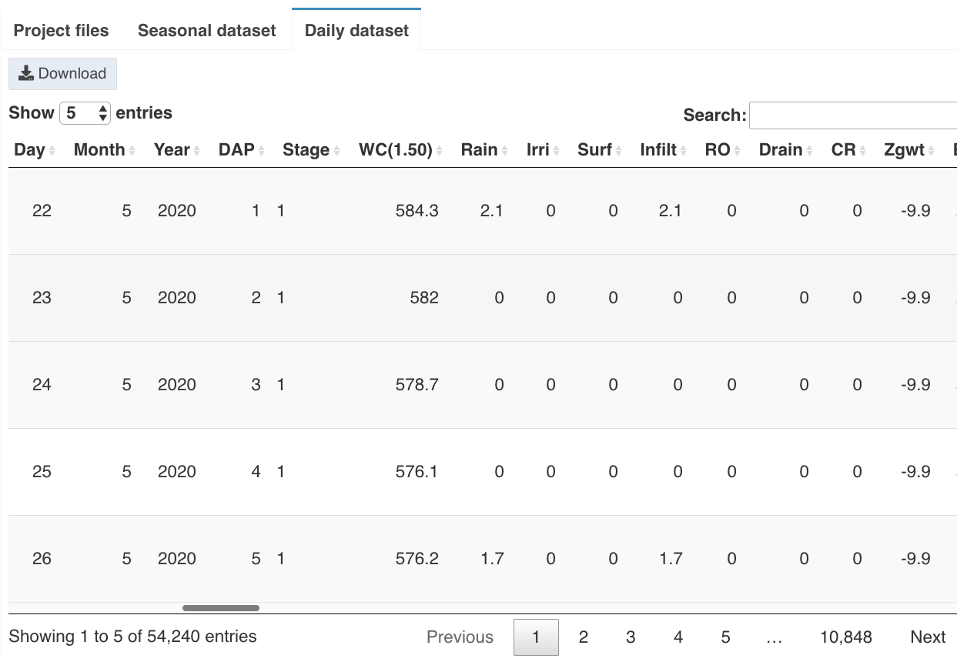

## 6.2 Rename column

The parameters and name variable automatically imported to the combined data are given default column names which can be changed by the user to reflect the values they contain and aid further analysis. This can be done using the Rename column toolbox. First select the column to rename then type the new name in the rename to box and click rename. For example, the extracted name.variable7 contains the climate model information so it is renamed climate_model.

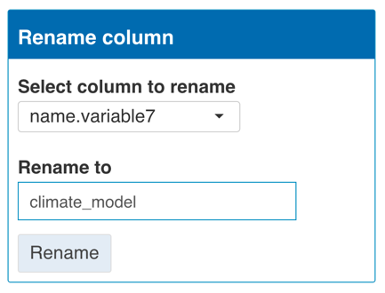

## 6.3 Filter dataset

In some cases, the data may need to be filtered to select only a subset of interest, for example, year range or specific subset of data from the simulation. This can be done using the Filter dataset toolbox. First select the column to filter by then select values to keep and click Filter. To undo all filtering and go back to the original dataset click Reset.

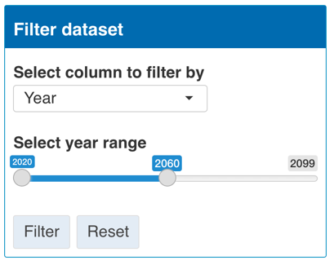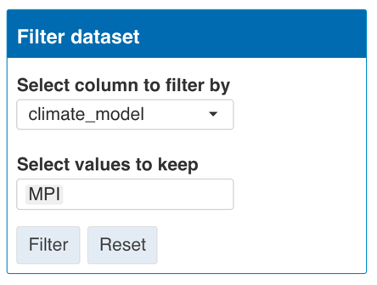

## 6.4 Advanced data labeling

### 6.4.1 Add custom labels by year range

This option allows custom labels to be added to a variable (column) in the dataset according to year range. For example, in some part of the simulation contains historical data so this year range can be specified and labeled as historical. This can be done using the Add custom labels by year range toolbox. First select the variable to add the label to, next select the year range to label, then type in the label and click Label. To undo all filtering and go back to the original dataset click Reset.

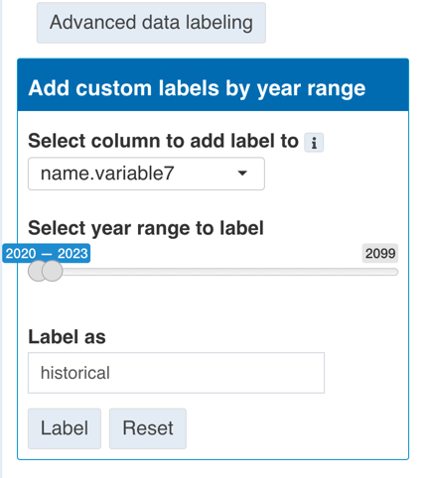

# 7. Plot

AquaCropPlotter can produce two main types of plots: Scatter plot and Box plot, which can be selected from the main side bar menu.

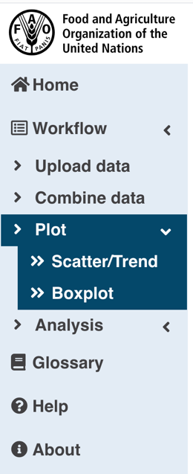

## 7.1 Scatter plot/ Trend/ Time series

### 7.1.1 Select plotting variables

First select data type to plot (daily or seasonal) then select variable to plot on the Y and X axis. Components of plot to show option allows user to add or remove different elements to the plot. Once all required options are selected, click Plot button to produce the plot. All the options selected can also be modified after plotting.

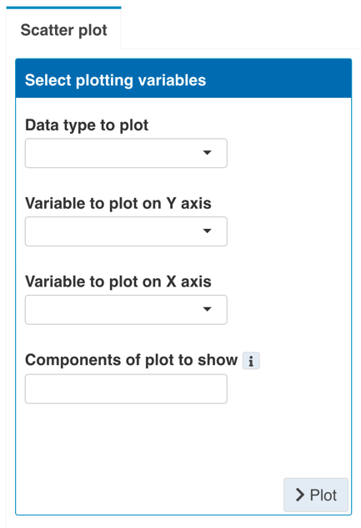

Components of plot to show includes:

- **point** - plot each data point as a point

- **line** - plot a line connecting each data point in order

- **linear_trend** - plot a linear trend line (linear regression) through the whole data

- **loess_smooth_trend** - plot a smooth trendline (Loess smoothing) through the whole data

- **background_grid** - show grid lines in the background of the plot

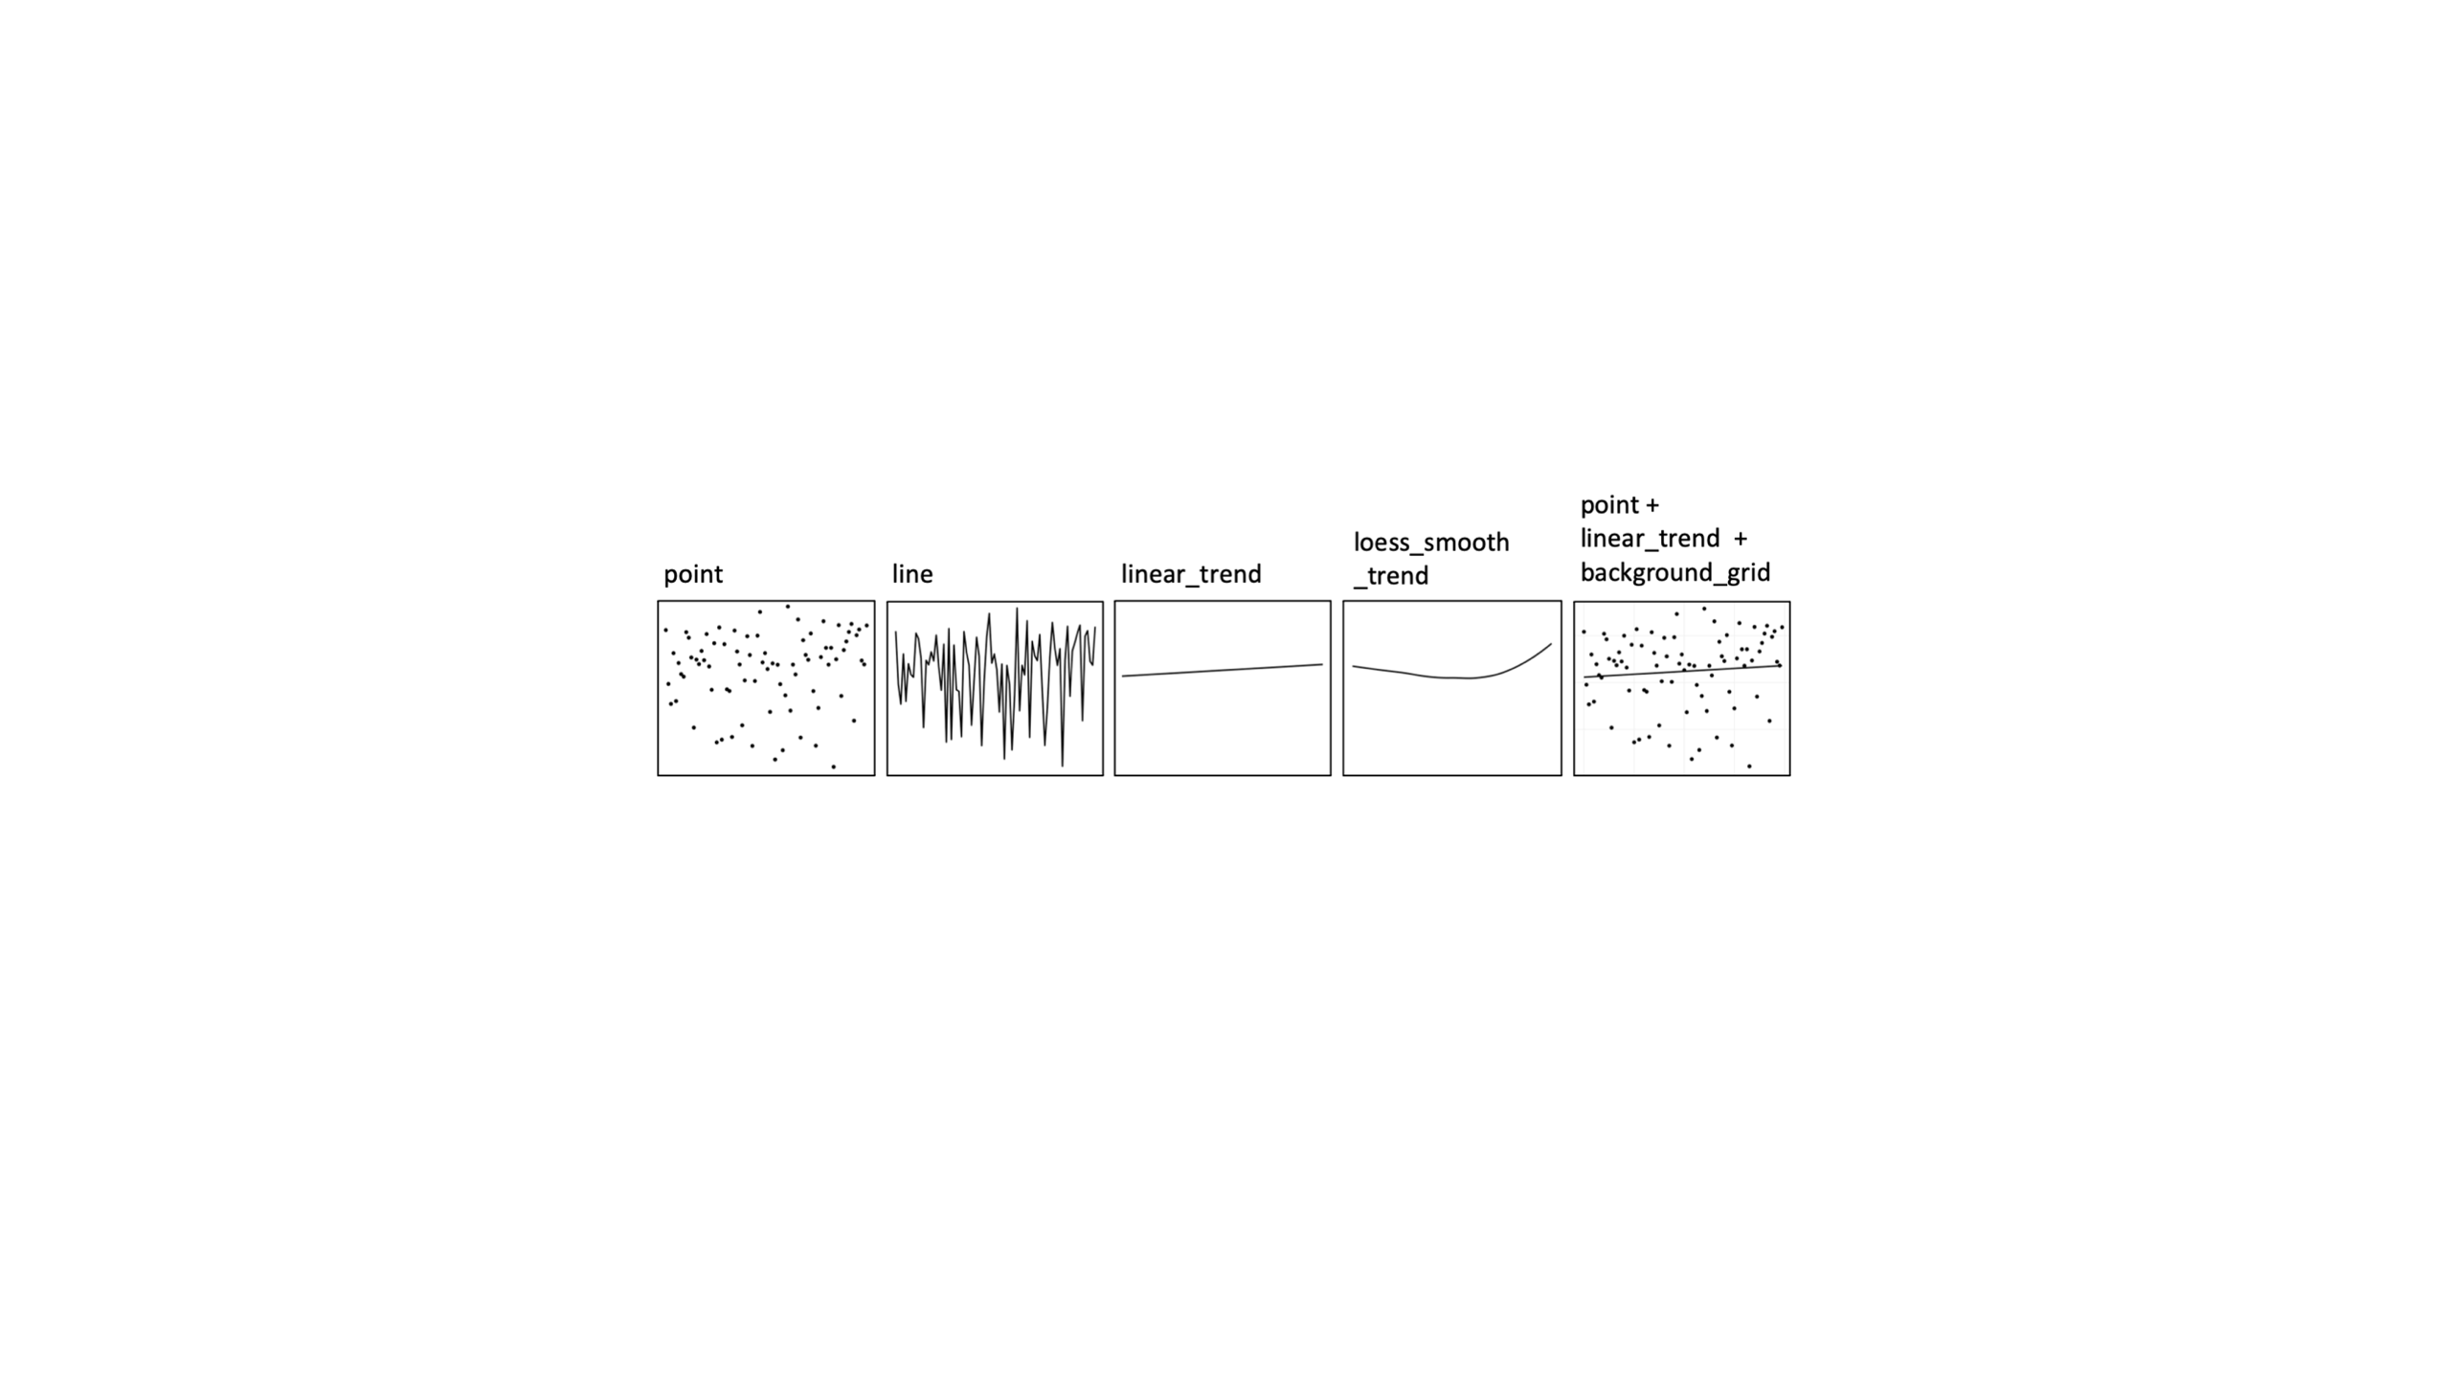

For example, we can produce a plot below from seasonal data type to see how yield on the Y axis (Y(dry)) changes over time on the X axis (Year1), showing data point, linear trend and background grid. By default, the plot will use all data from the whole dataset to plot.

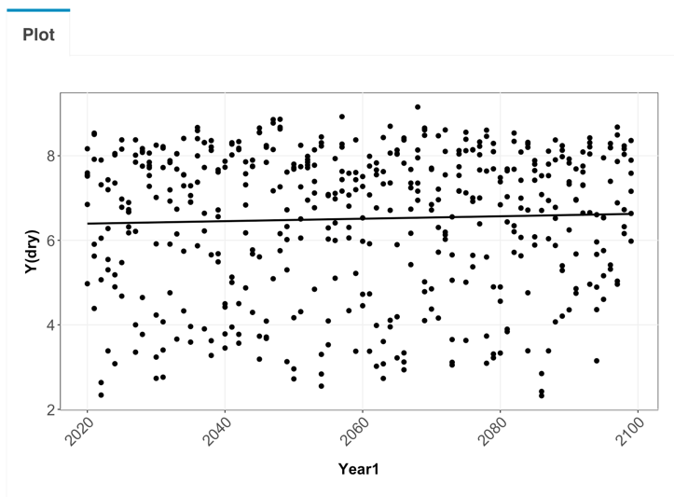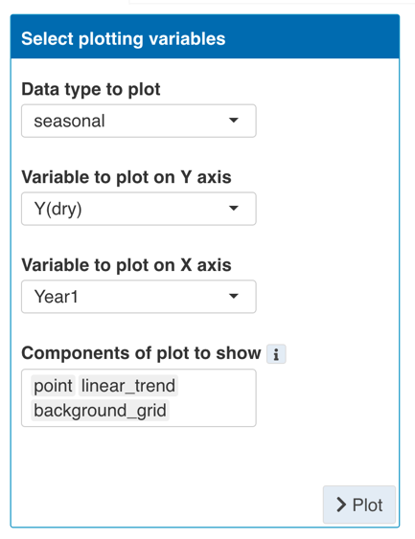

### 7.1.2 Select grouping variables

It is often useful to show different subset or groups in the data to allow comparisons. Different grouping information can be depicted by different colors, point shapes or line types. Different groups can also be split into subpanels arranged by columns and rows, respectively.

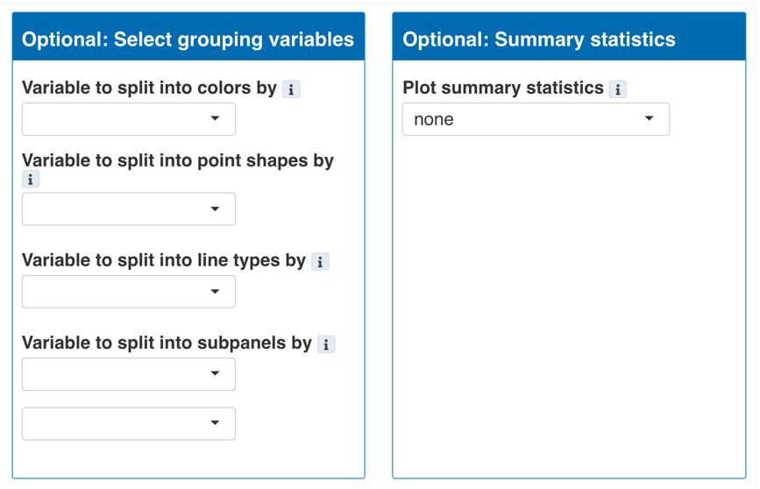

For example, from the initial plot above (section 7.1.1), we can display different locations in different subpanel arranged in columns and different climate_model in different colors. This way we can compare the results from simulations from different locations based on different climate models.

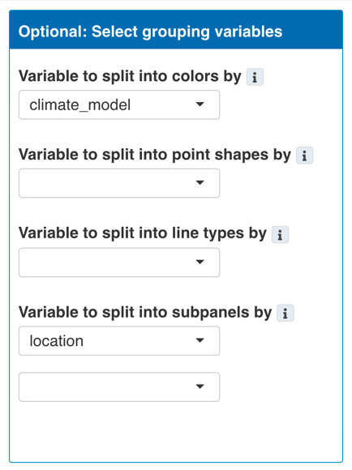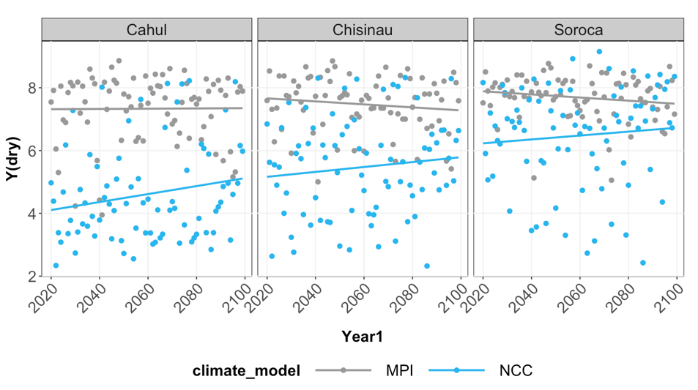

### 7.1.3 Summary statistics

In some cases, it is useful to plot data using summary statistics instead of all data points. Summary statistics options can be selected from the list and the plot will summarise data into the chosen summary statistics to plot, keeping the grouping variable previously selected as well as having an option to supply extra grouping variables to further divide the groups to calculate summary statistics.

By default, summary statistics are calculated on the whole set of data subdivided only by grouping variables supplied by the user. This means a grouping variable should be supplied if that particular grouping information needed to be displayed.

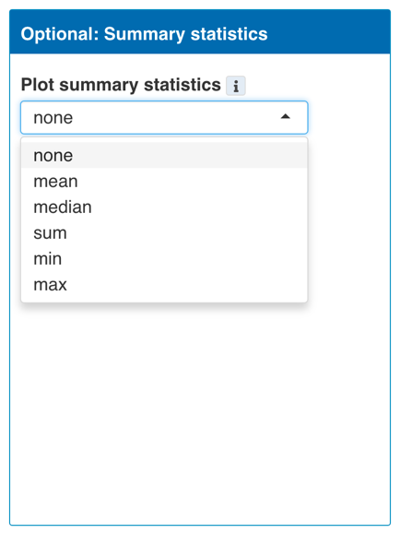

For example, from the plot above (section 7.1.2), we can summarise the data from two climate models into one mean, instead of showing two climate models in two colors.

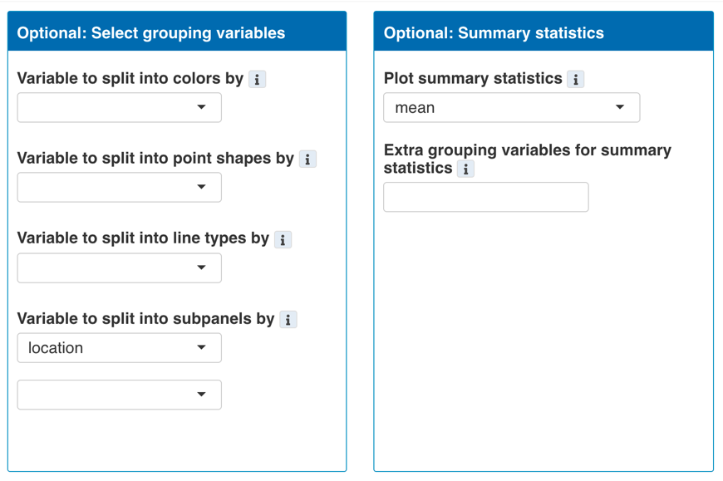

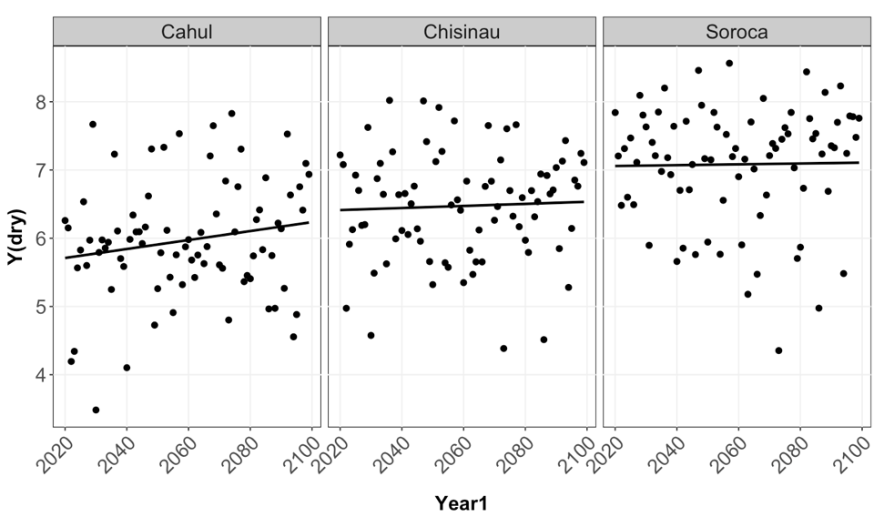

### 7.1.4 Customise and export plot

To customise plot apperance and export plot, click the Customise & export plot button above the plot to show the extra toolboxes.

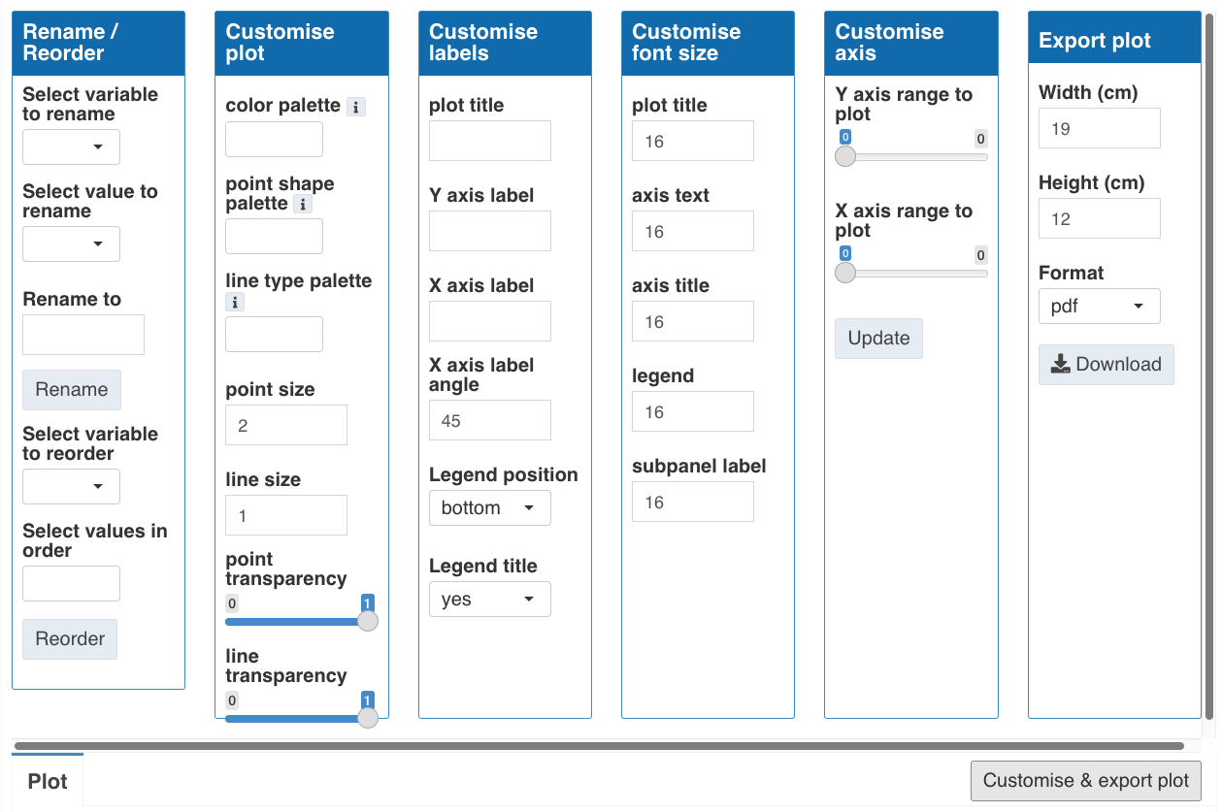

**7.1.4.1 Rename/ Reorder**

- **Rename**

Variables used in the plot can be rename in the final plot display. First, select the variable to rename, next select the value to rename, then type the new name into rename to box and click Rename button.

- **Reorder**

The order of variables to appear in the plot, such as when arranged into subpanels or grouping into different colors, can be arranged manually. First, select the variable to reorder, then all the values of the variable will be available in the list to be selected in the new order. Click to select values in the order they are to be reordered i.e. click the first value first then second value etc.

**7.1.4.2 Customise plot**

- **color palette** - customise the color used for each value of the variable selected to be split into colors by. The same number of colors as the number of distinct values to represent should be chosen. The order that the colors are selected should be the same as the order that they are used for each value of the variable. For example, if the variable location has 2 values (A and B), which are to be colored blue and orange, respectively, then two colors from the color palette choice should be selected, with blue selected first then orange.

- **point shape palette -** customise the point shapeused for each value of the variable selected to be split into point shapes by. The same number of point shapesas the number of values to represent should be chosen. The order that the point shapesare selected should be the same as the order that they are used for each value of the variable. For example, if the variable location has 2 values (A and B), which are to be shaped rectangle and triangle, respectively, then two point shapes from the point shape palette choice should be selected, rectangle first then triangle.

- **line type palette -** customise the line type used for each value of the variable selected to be split into line types by. The same number of line types as the number of values to be colored should be chosen. The order that the line types are selected should be the same as the order that they are used for each value of the variable. For example, if the variable location has 2 values (A and B), which are to be solid and dotted, respectively, then two line types from the line type palette choice should be selected, solid first then dotted.

- **point size** - type in the size of points in the plot

- **line size** - type in the thickness of lines in the plot

- **point transparency** - slide to choose the transparency of points in the plot (from transparent [0] to full color[1])

- **line transparency** - slide to choose the transparency of lines in the plot (from transparent [0] to full color[1])

**7.1.4.3 Customise labels**

- **plot title** - type in the plot title to be displayed on top of the plot

- **Y axis label** - type in the Y axis label

- **X axis label** - type in the X axis label

- **X-axis angle** - type in the angle of X axis label. This can be tilted to avoid overlaps.

- **legend position** - select the position of the legend relative to the plot (right, bottom, or none)

- **legend title** - if yes, the title of the legend is displayed, if no, only the values are displayed

**7.1.4.4 Customise font size**

type in the font size of each text element of the plot

- **plot title**

- **axis title**

- **axis text**

- **legend**

- **subpanel label**

**7.1.4.5 Customise axis**

- **Y axis range to plot** - slide to select the range of minimum and maximum value to plot on the Y axis then click update button

- **X axis range to plot** - slide to select the range of minimum and maximum value to plot on the X axis then click update button

**7.1.4.6 Export plot and plot size**

- **Width** - specify the width of the plot to be exported in cm. This width is also used to scale the plot that is displayed in the app.

- **Height** - specify the height of the plot to be exported in cm. This height is also used to scale the plot that is displayed in the app.

- **Format** - choose the format of the plot to be exported as (.pdf or .png)

- **Download** button - click to save the plot

## 7.2 Boxplot

### 7.2.1 Select plotting variables

First select variable to plot on the Y and X axis. The Y axis variable is a numeric variable of interest to be plotted, while the X axis variable is a categorical variable used to group data points into different boxes. Once all required options are selected, click Plot button to produce the plot. All the options selected can also be modified after plotting.

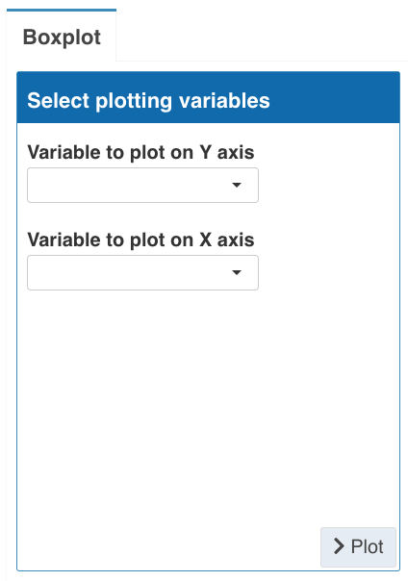

For example, we can produce a plot below to see how yield on the Y axis (Y(dry)) are different in different locations. By default, the plot will use all data from the whole dataset.

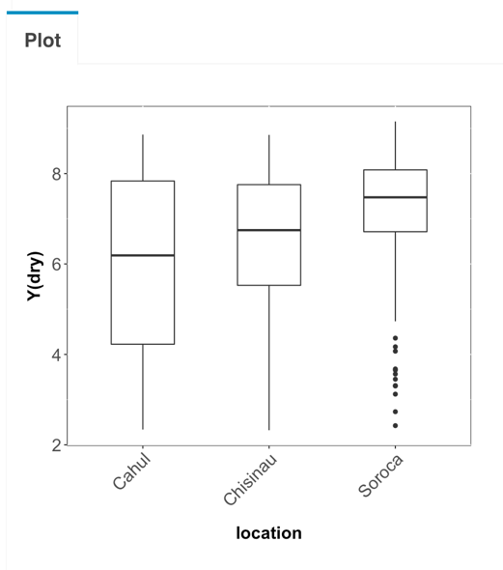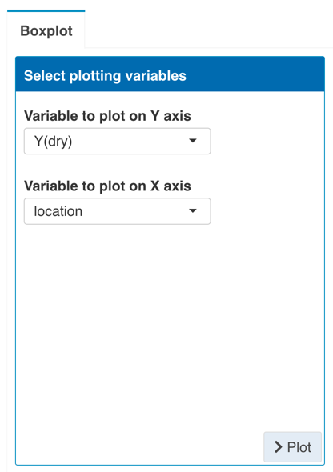

### 7.2.2 Select grouping variables

It is often useful to show different subset or groups in the data to allow comparisons. Different grouping information can be depicted by boxes with different colors. Different groups can also be split into subpanels arranged by columns and rows, respectively.

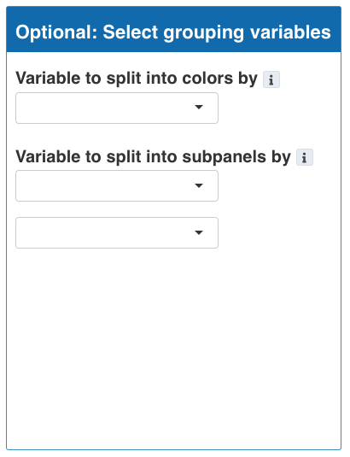

For example, from the initial plot above (section 7.2.1), we can display different climate_model in different colors and subpanels. This way we can compare the results from simulations based on different climate models.

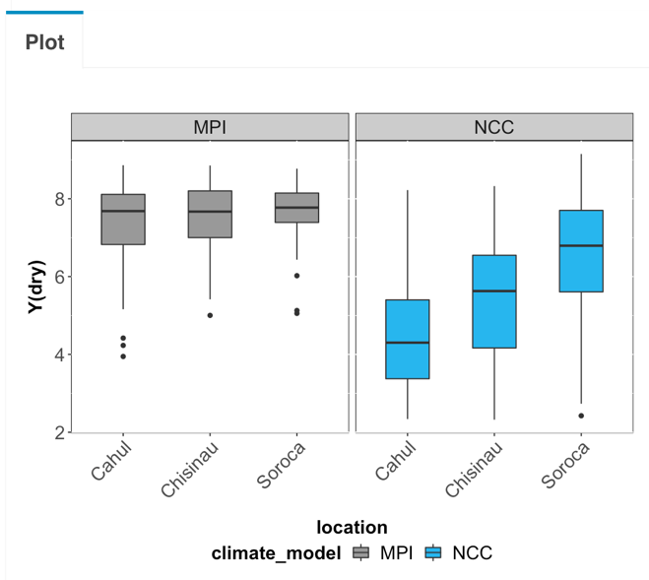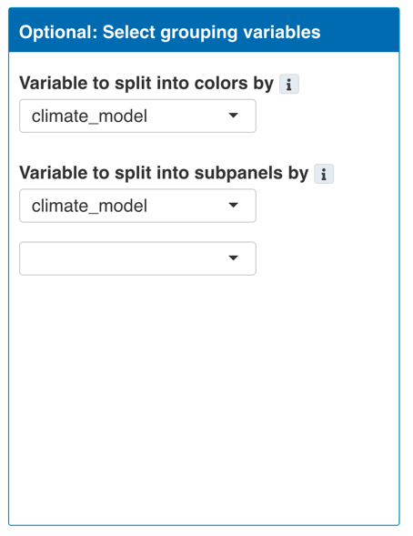

**Split plot into subpanels by time horizons**

In some cases, it is also useful to see the changes in the variable of interest over periods of time. The boxplots can be split into subpanels arranged in columns by different time horizons. To do this, first, select time.horizon as a variable to split into subpanels by, then select time horizon duration to be used to subset the data.

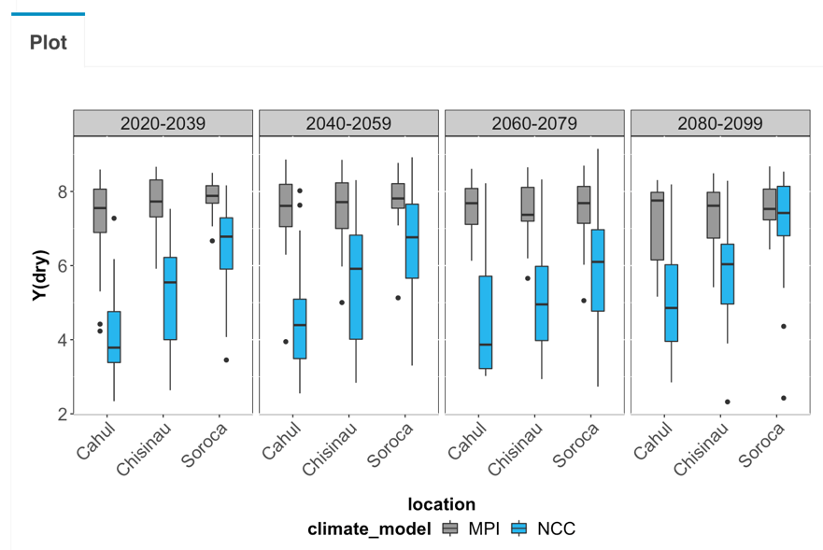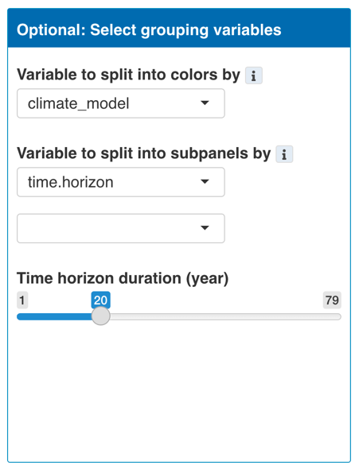

### 7.2.3 Plot values relative to an average from reference period

For some analyses, the emphasis is on the change a variable of interest compared to a reference period (e.g. historical period). To do this, first, select yes for the Plot relative values option, then select the reference period year range. The data displayed on the plot will be calculated as a percentage of change relative to the average from the selected reference period. The calculated relative data can also be downloaded with the Download relative data button.

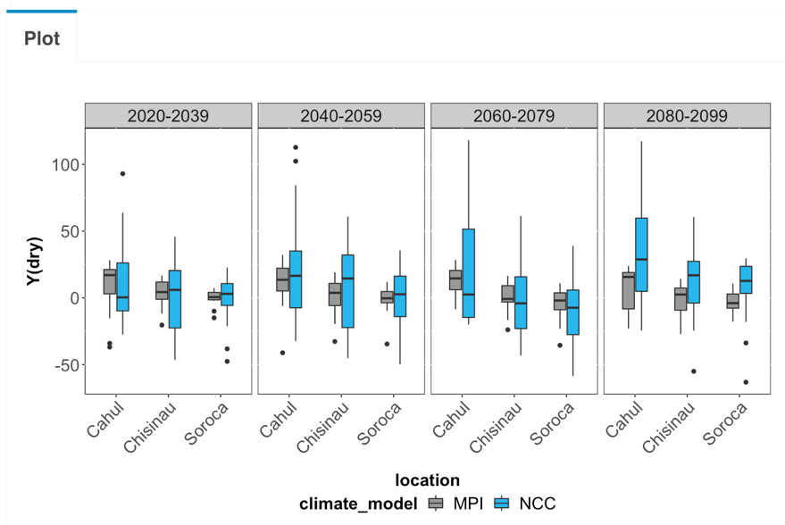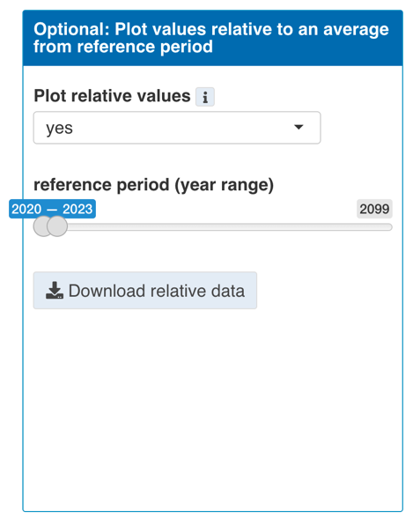

### 7.2.4 Customise and export plot

To customise plot apperance and export plot, click the Customise & export plot button above the plot to show the extra toolboxes.

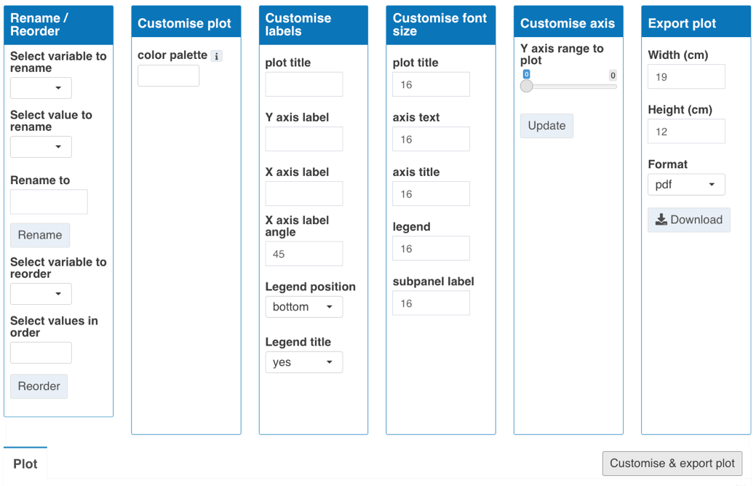

**7.1.4.1 Rename/ Reorder**

- **Rename**

Variables used in the plot can be rename in the final plot display. First, select the variable to rename, next select the value to rename, then type the new name into rename to box and click Rename button.

- **Reorder**

The order of variables to appear in the plot, such as when arranged into subpanels or grouping into different colors, can be arranged manually. First, select the variable to reorder, then all the values of the variable will be available in the list to be selected in the new order. Click to select values in the order they are to be reordered i.e. click the first value first then second value etc.

**7.1.4.2 Customise plot**

- **color palette** - customise the color used for each value of the variable selected to be split into colors by. The same number of colors as the number of distinct values to represent should be chosen. The order that the colors are selected should be the same as the order that they are used for each value of the variable. For example, if the variable location has 2 values (A and B), which are to be colored blue and orange, respectively, then two colors from the color palette choice should be selected, with blue selected first then orange.

**7.1.4.3 Customise labels**

- **plot title** - type in the plot title to be displayed on top of the plot

- **Y axis label** - type in the Y axis label

- **X axis label** - type in the X axis label

- **X-axis angle** - type in the angle of X axis label. This can be tilted to avoid overlaps.

- **legend position** - select the position of the legend relative to the plot (right, bottom, or none)

- **legend title** - if yes, the title of the legend is displayed, if no, only the values are displayed

**7.1.4.4 Customise font size**

type in the font size of each text element of the plot

- **plot title**

- **axis title**

- **axis text**

- **legend**

- **subpanel label**

**7.1.4.5 Customise axis**

- **Y axis range to plot** - slide to select the range of minimum and maximum value to plot on the Y axis then click update button

**7.1.4.6 Export plot and plot size**

- **Width** - specify the width of the plot to be exported in cm. This width is also used to scale the plot that is displayed in the app.

- **Height** - specify the height of the plot to be exported in cm. This height is also used to scale the plot that is displayed in the app.

- **Format** - choose the format of the plot to be exported as (.pdf or .png)

- **Download** button - click to save the plot

# 8. Analysis

## 8.1 Time window summary

This analysis function calculates summary statistics of variables of interest in the time range broken down into specified time windows. This option includes the following 4 steps:

- select the year range to analyse. This can be the whole dataset or a subset of years of interest.

- select time period window size (years). The data will be divided into subsets of the specified time window size.

- select the variable to calculate summary statistics for.

- select grouping variables to further specify groups in the data to allow comparisons.

The dataset will be subdivided into groups by the specified time windows and grouping variables, then data in each group are used separately to calculate summary statistics, including mean, standard deviation, coefficient of variation and number of data points included in each summary calculation (n). The results and their grouping variables are displayed in a table, which can also be downloaded.

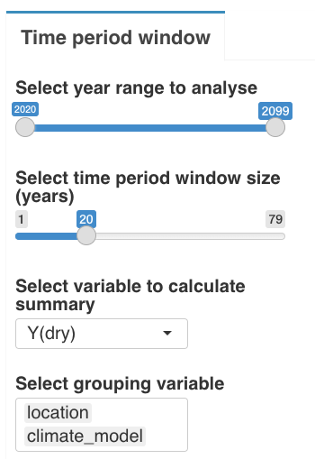

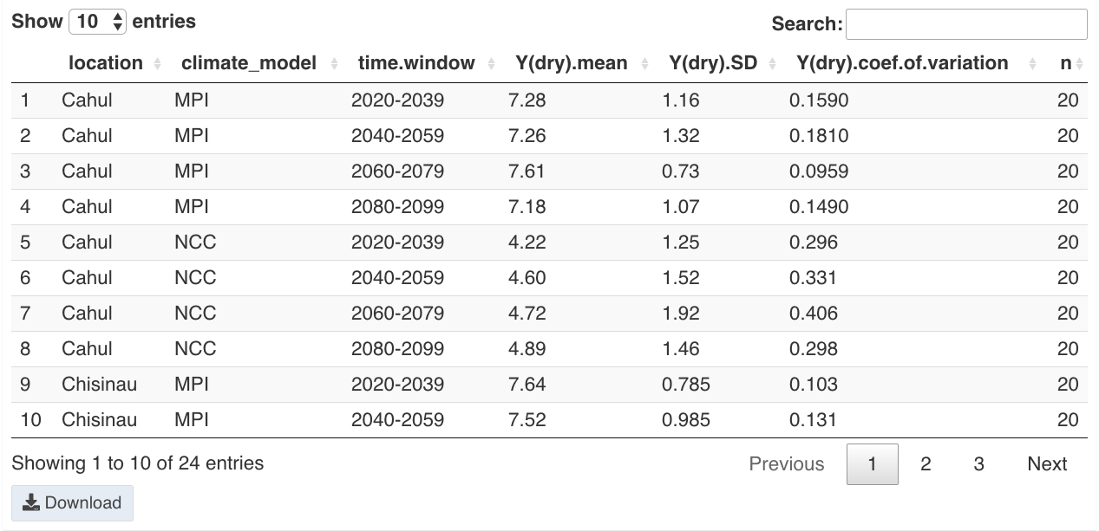

## 8.2 Regression

This analysis function fit a simple linear regression model on the dataset. This option includes the following 4 steps:

- select data type. Choose from daily or seasonal data to be used for the regression.

- select dependent (Y) variable.

- select independent (X) variable.

- select grouping variables to further specify groups in the data to allow comparisons.

The selected dataset will be subdivided into groups by the grouping variables, then data in each group are used separately to fit a simple linear regression model and return model estimates including R-squared, slope and p-value of the model. The results and their grouping variables are displayed in a table, which can also be downloaded.

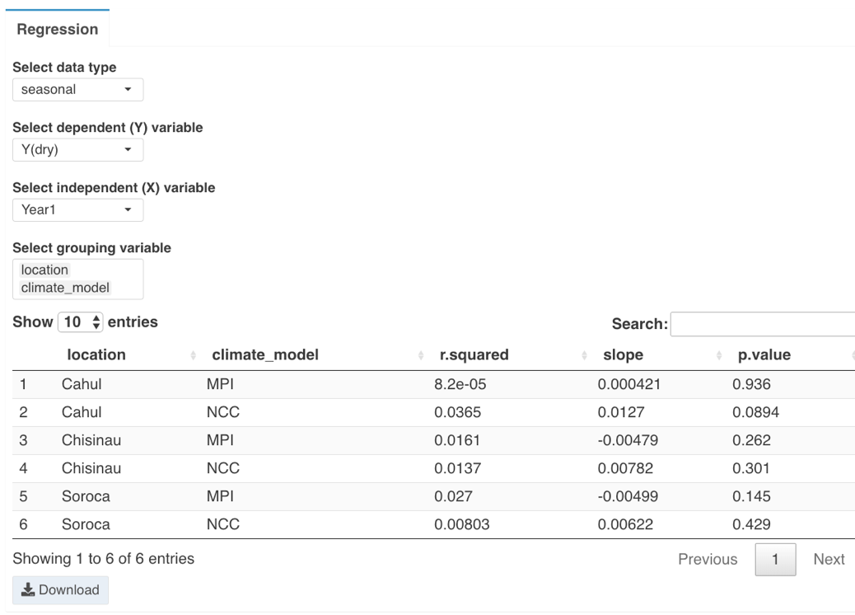

# 9. Case Study

## 9.1 AquaCrop GUI

This case study will go through an example dataset from AquaCrop GUI version. This example contains one simulation done on one cropping season. There are 10 output files (9 .OUT files for simulation data and 1 .PRM file for project and parameter details).

### 9.1.1 Upload data

First, we need to upload the data into the app. Navigate to Upload data tab, select AquaCrop programme used as GUI. Then in Data and PRM files box, click Browse to upload all 10 AquaCrop output files from your computer in one batch. Once the upload and processing are complete, the list of uploaded files is shown in the Uploaded files box.

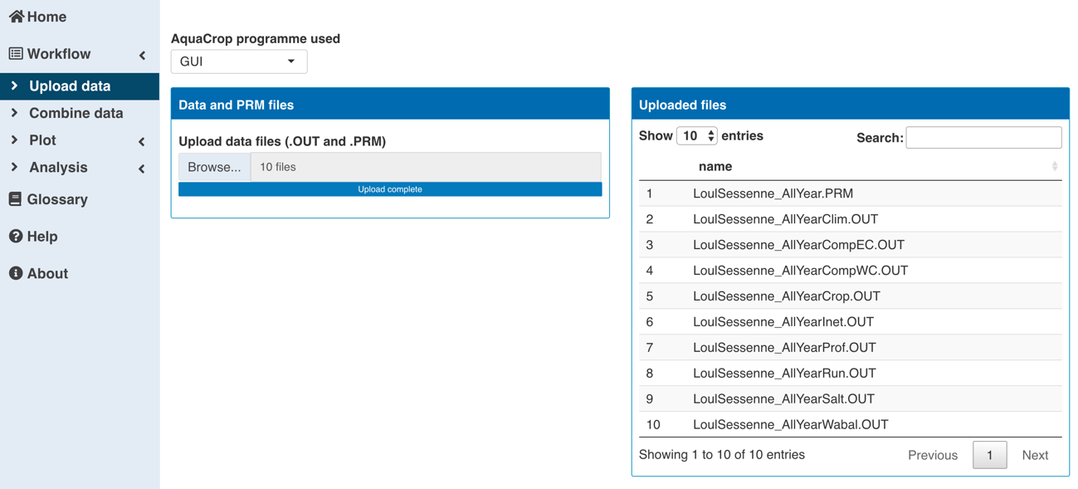

### 9.1.2 Combined data

After uploading, we can see the data that has been processed and organised in the app. Navigate to Combined data tab, all the data are sorted according to their data type and combined into 3 data tables, which are accessible via the 3 tabs on top of the page:

- Project files: containing information extracted from the PRM file and file name

- Seasonal dataset: containing simulation results of the season

- Daily dataset: containing simulation results of each day in the season

The tables are scrollable to see all columns of the dataset. If there are too many rows, such as for many days in the daily dataset, the table is split into multiple pages. This data table can also be downloaded by clicking the Download button above the table.

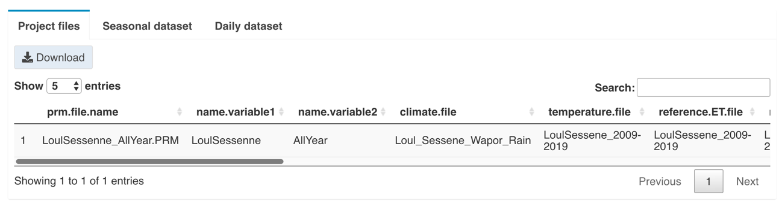

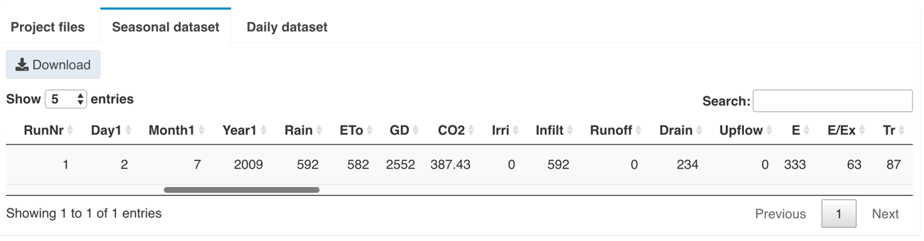

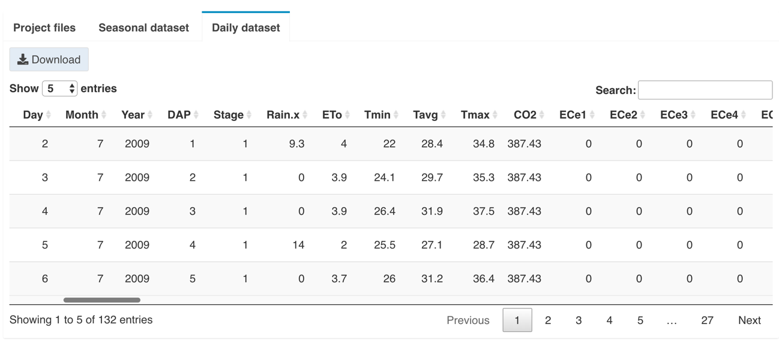

### 9.1.3 Plot

Next, we can explore and visualise the data. Navigate to the Plot tab and select Scatter/Trend. Since this simulation was run for only one cropping season, it is not interesting to plot seasonal data which has only one data point. However, it is interesting to see how the simulation results develops during the cropping period in the daily dataset. To plot this dataset, select Data type to plot as daily. Now we can select different variables for the Y and X axis to plot.

For example, to see the change of a variable over time during the period of simulation, date can be chosen as the variable to plot on X axis. Then the variable of interest such as biomass can be chosen as variable to plot on Y axis. Different components of plot to show can be selected, in this case just line and background_grid. Click Plot button to produce the plot. Below we can see how the crop biomass changes during the growing season.

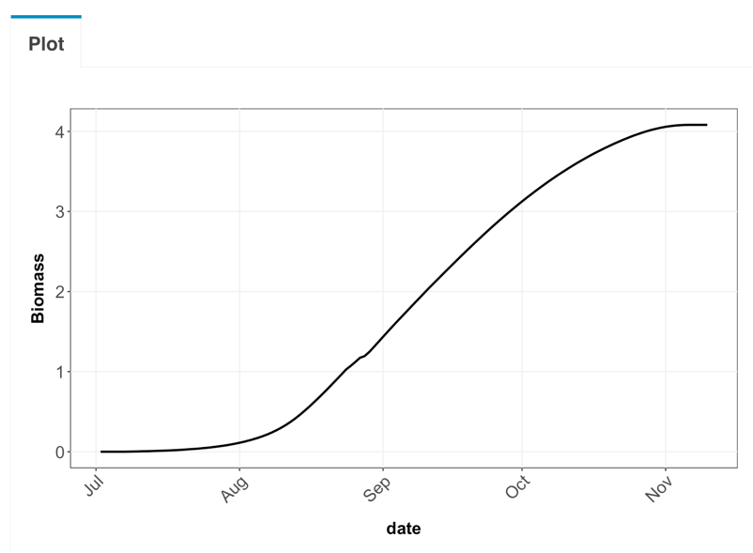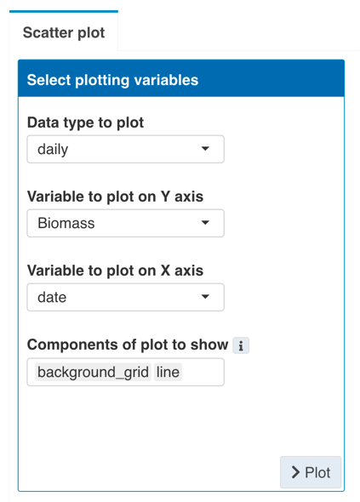

The plot can then be customised and exported. Click Customise & export plot button above the plot to show toolboxes.

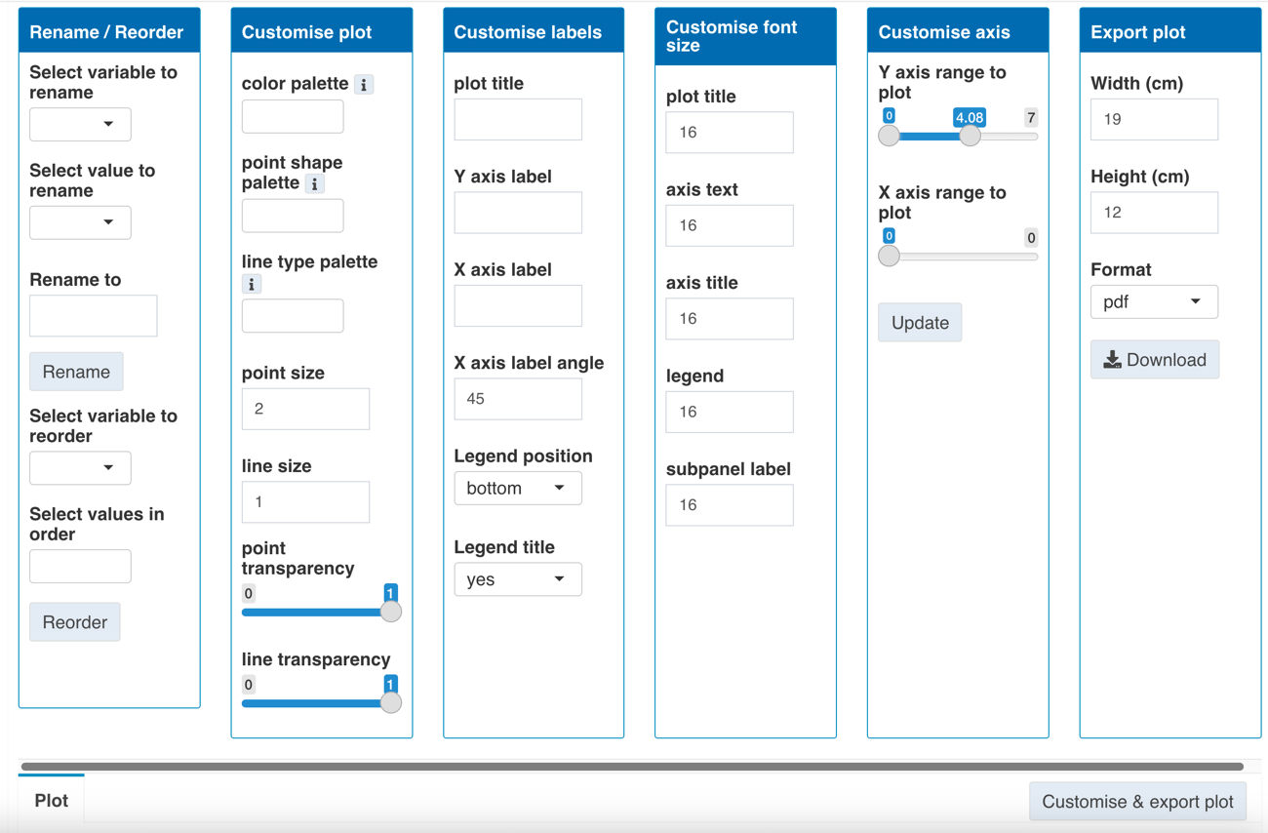

## 9.2 AquaCrop Plug-in

This case study will go through an example dataset from AquaCrop Plug-in version. This example contains 6 simulations done across 3 locations (Cahul, Chisinau and Soroca) using 2 climate models (MPI and NCC) each. There are 18 output files (each simulation has 3 files: .PRM file for project and parameter details, season.OUT file for seasonal data and day.OUT file for daily data).

### 9.2.1 Upload data

First, we need to upload the data into the app. Navigate to Upload data tab, select AquaCrop programme used as plugin. Then in Batch upload all files box, click Browse to upload all 18 AquaCrop output files from your computer in one batch. Once the upload and processing are complete, the list of uploaded files are shown in the boxes below, sorted into 3 file types.

To supply information associated with each simulation, the files are named according to the naming convention, i.e. with variable separated by underscore. These name variables are automatically detected by the app and shown underneath the file upload box. In this example, 7 variables were detected.

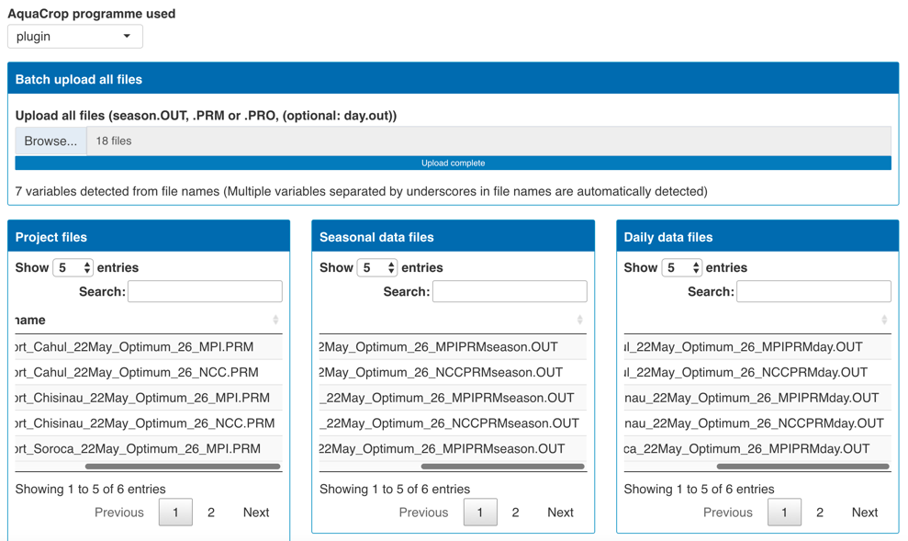

### 9.2.2 Combined data

After uploading, we can see the data that has been processed and organised in the app. Navigate to Combined data tab, all the data are sorted according to their data type and combined into 3 data tables, which are accessible via the 3 tabs on top of the page:

- **Project files**: containing information extracted from the PRM file and file name. In this example, there are 6 simulations so the 6 project files together with their information are in this table.

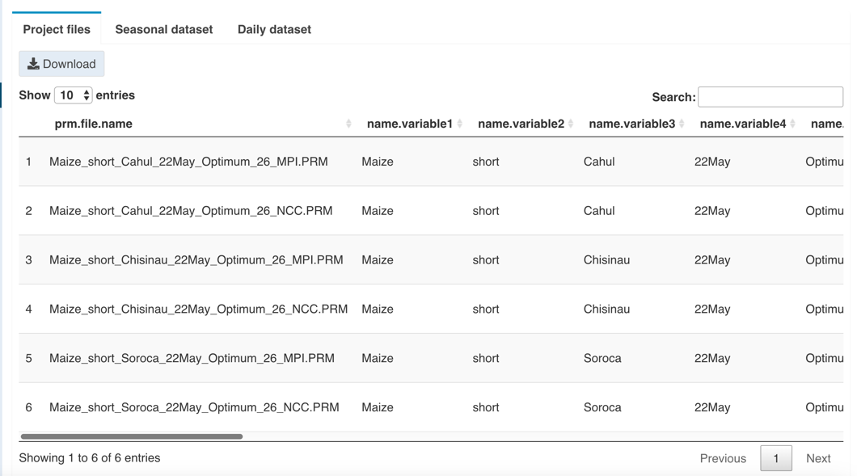

- **Seasonal dataset**: containing simulation results of the season. In this example, each simulation runs for 80 years from 2020-2099. Each row of data is each year of each simulation.

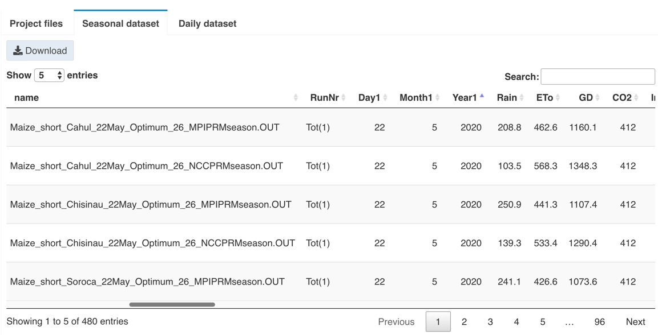

- **Daily dataset**: containing simulation results of each day in the season. In this example, each simulation was run with the season starting on 22 May until 1 Sep each year. Each row of data is each day of each simulation.

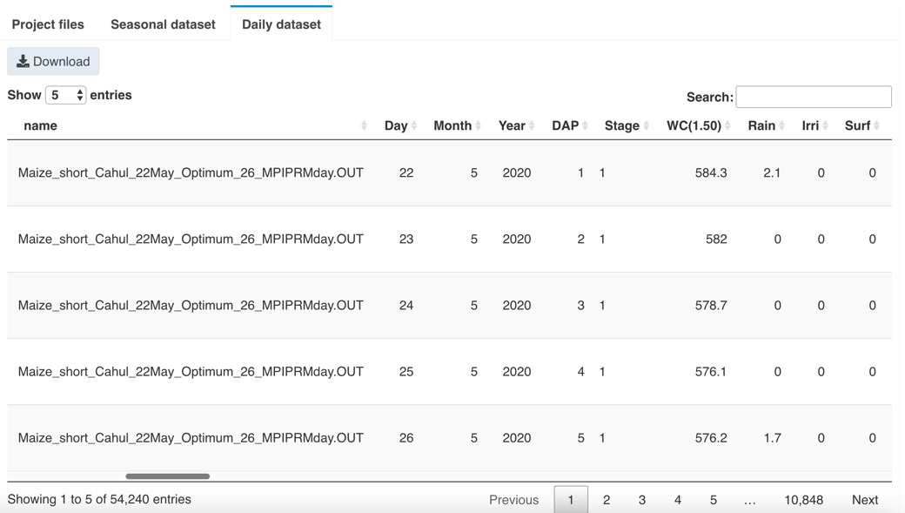

The tables are scrollable to see all columns of the dataset. If there are too many rows, such as for many days in the daily dataset, the table is split into multiple pages. This data table can also be downloaded by clicking the Download button above the table.

The name variable extracted from file names are contained in name variable columns, which can be renamed to reflect the values they contain. In this example, name.variable 3 is location and name.variable7 is climate_model. Go to Rename column toolbox, Select column to rename, then type in the new name in Rename to box and click Rename button. Now, the data table displays the renamed columns.

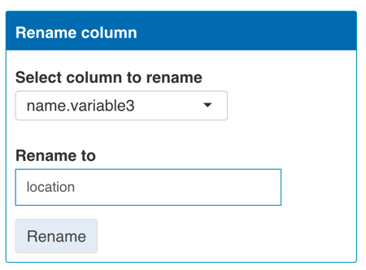

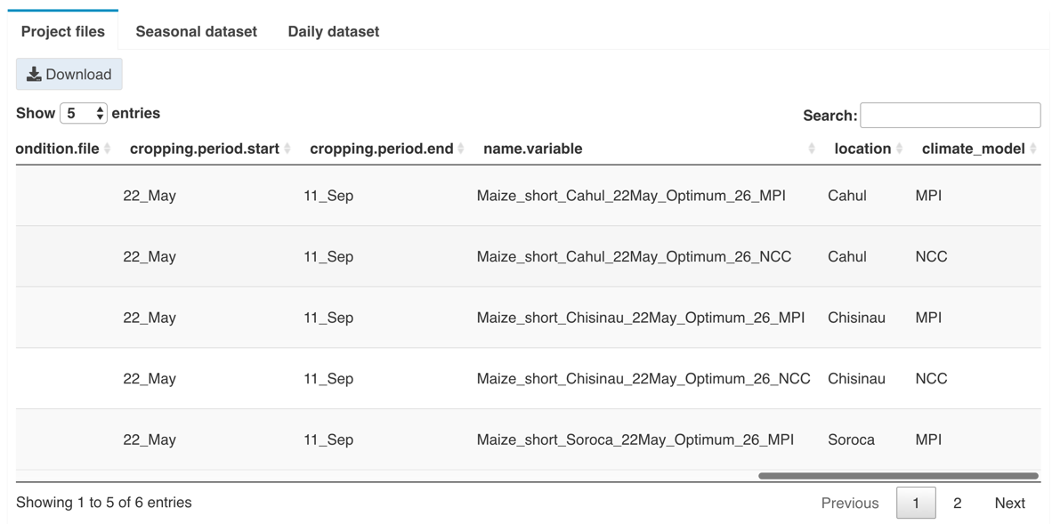

### 9.2.3 Plot

**9.2.3.1 Scatter/ Trend plot**

Next, we can explore and visualise the data. This first example will be Scatter/Trend plot. Navigate to the Plot tab and select Scatter/Trend. This simulation was run for over 80 years and we are interested in seeing the projection over multiple seasonal data but not necessarily details of daily data, which also contain too many days. To plot this dataset, select Data type to plot as seasonal. Now we can select different variables for the Y and X axis to plot.

For example, to see the change of a variable over time during the period of simulation, Year1 can be chosen as the variable to plot on X axis. Then the variable of interest such as yield (Y(dry)) can be chosen as variable to plot on Y axis. Different components of plot to show can be selected, we can select point for each data point and background_grid. Click Plot button to produce the plot. Below we can see how the yield changes over the years. To help see the trend clearer, a trend line can also be added, select linear_trend as another component of plot to show.

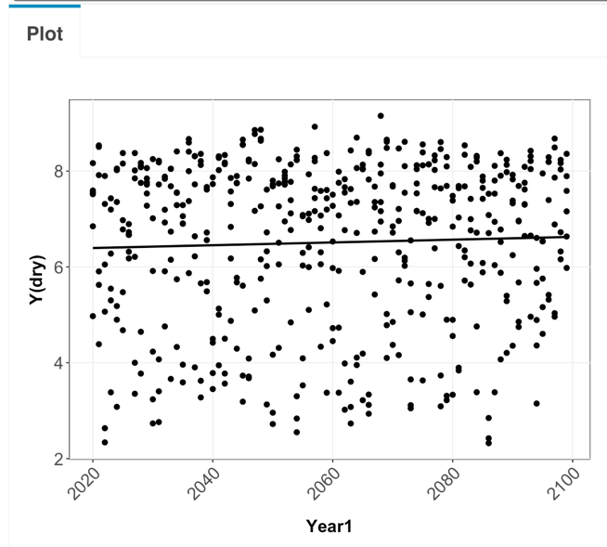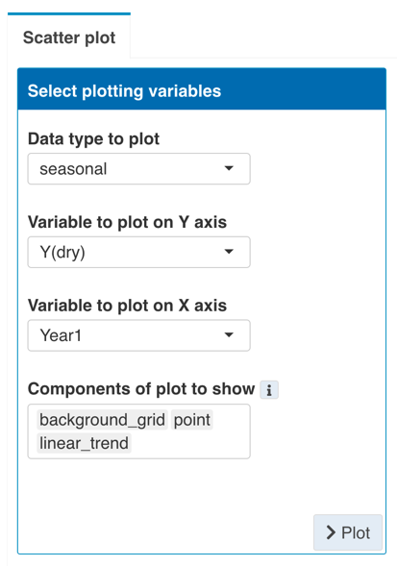

By default, the app plots every data points available from the data uploaded altogether. We can see that this first plot has many data points. To explore and compare different simulations, additional grouping variables can be added using the Select grouping variables toolbox. Grouping information can be depicted in various ways. In this case, the different climate_model is split into different colors and different locations are split into different subpanels arranged by the columns. Select these variables in the corresponding boxes. The plot is then updated automatically. Now we can see the patterns in different locations and climate_models.

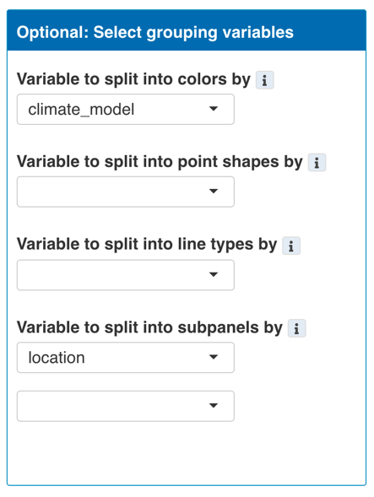

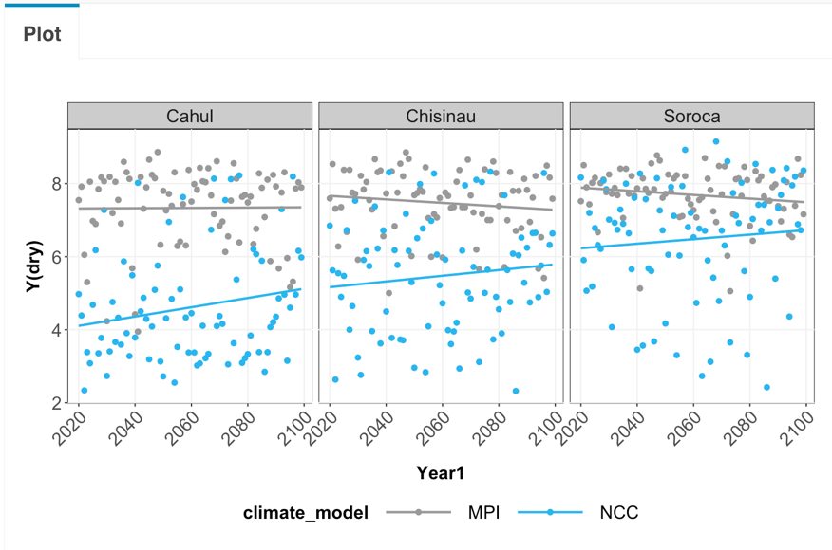

Next, we might want to calculate summary statistics to represent the data or simplify the plot. This can be done using the Summary statistics toolbox. Select the options from Plot summary statistics box. In this example, we will plot the mean of the yield from the two climate_models, instead of plotting separately in different colors. By default, summary statistics are calculated on the whole data available unless there are grouping variables supplied, which are used to split the data into subset to calculate summary statistics. In this case, only location is supplied as grouping variables so the data are split into 3 subsets by locations, then all data within each subsets are used to calculate summary statistics (mean). Now each data point is the mean of 2 data points from two climate models.

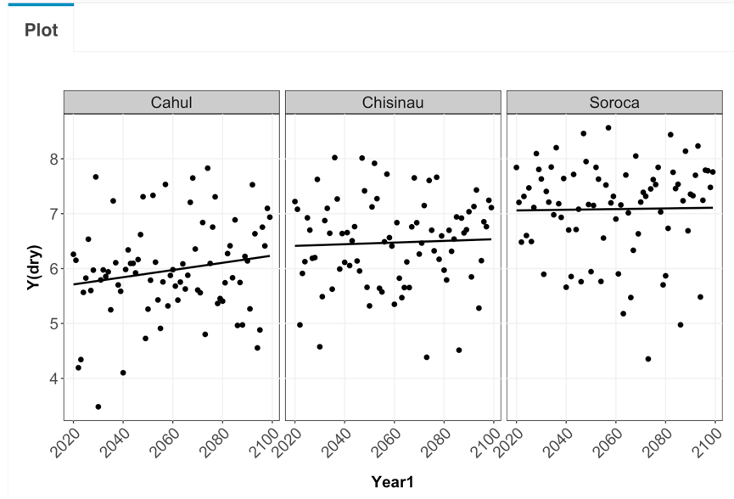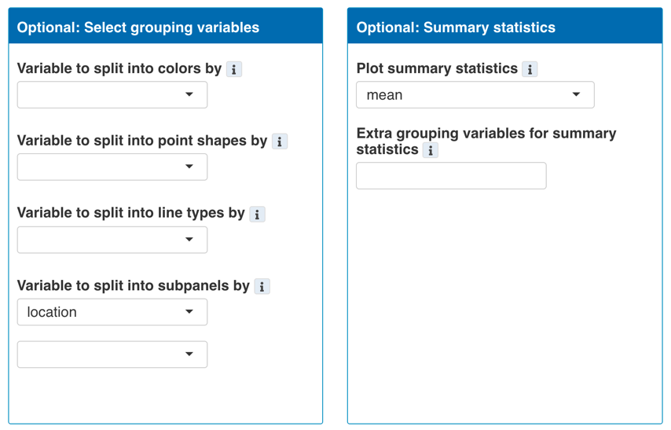

The plot can also be customised and exported to be used in reports. Click Customise & export plot button above the plot to show available toolboxes.

To illustrate the customisation options, we will use the plot above showing different locations and climate models.

In the Rename/ Reorder toolbox, values of variable displayed on the plot can be renamed. For example, we can add extra information to the name of location. Select variable to rename, then elect the value to rename, type the new name to rename to and click Rename button. In this example, we just add extra letters (A, B or C) to each location name.

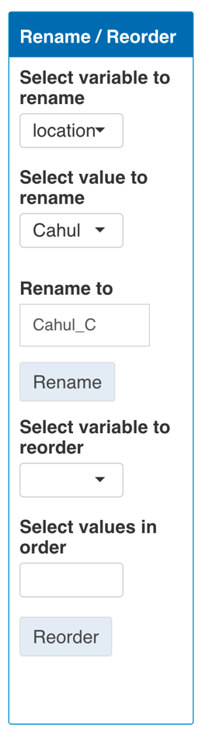

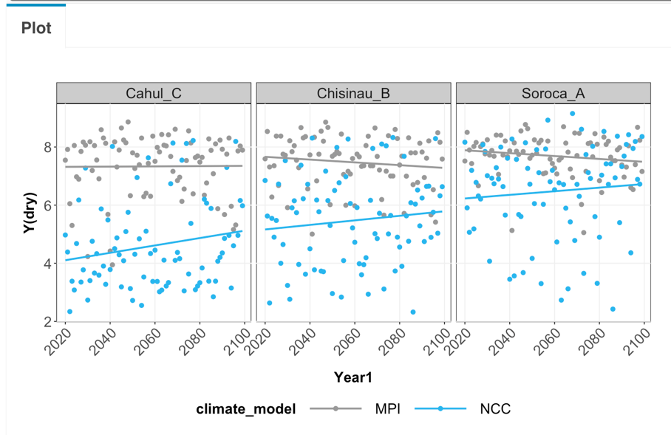

In the Rename/ Reorder toolbox, values of variable displayed on the plot can also be reordered. For example, we can specify the order of variables to appear in the plot, such as when arranged into subpanels or grouping into different colors. First, select the variable to reorder, then all the values of the variable will be available in the list to be selected in the new order. Click to select values in the order they are to be reordered i.e. click the first value first then second value etc, then click Reorder button. In this example, we reorder the location by the letters we just added alphabetically.

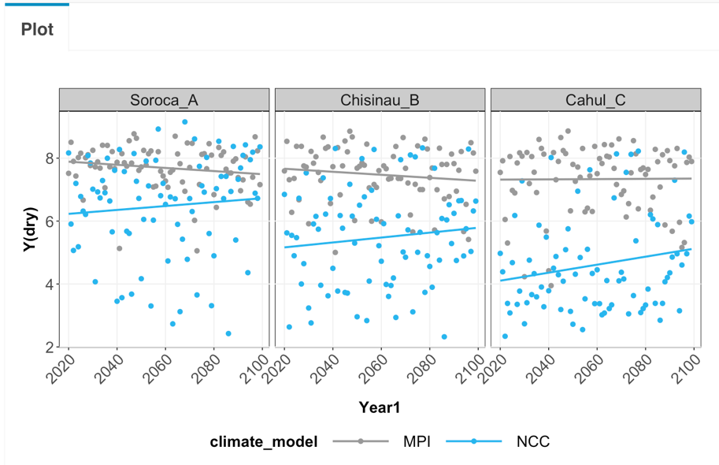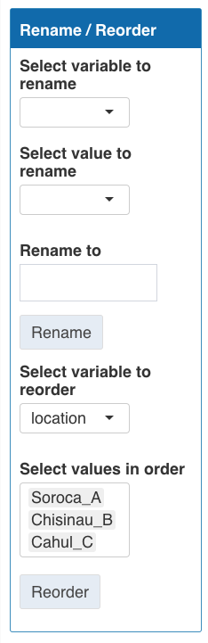

Next, Customise plot toolbox provides options to customise the appearance of the plot. For example, we can change the color used for each value of the variable selected to be split into colors by. The same number of colors as the number of distinct values to represent should be chosen. The order that the colors are selected should be the same as the order that they are used for each value of the variable. In this example, we will recolor the climate_model MPI to orange and NCC to blue. Since MPI is the first value in the climate_model variable and NCC is the second value, color palette is chosen orange followed by blue. As another example, point transparency can also be reduced to emphasise the trend line and declutter the plot. The point transparency slider bar can be moved down to half (50% transparency). The plot below is then produced.

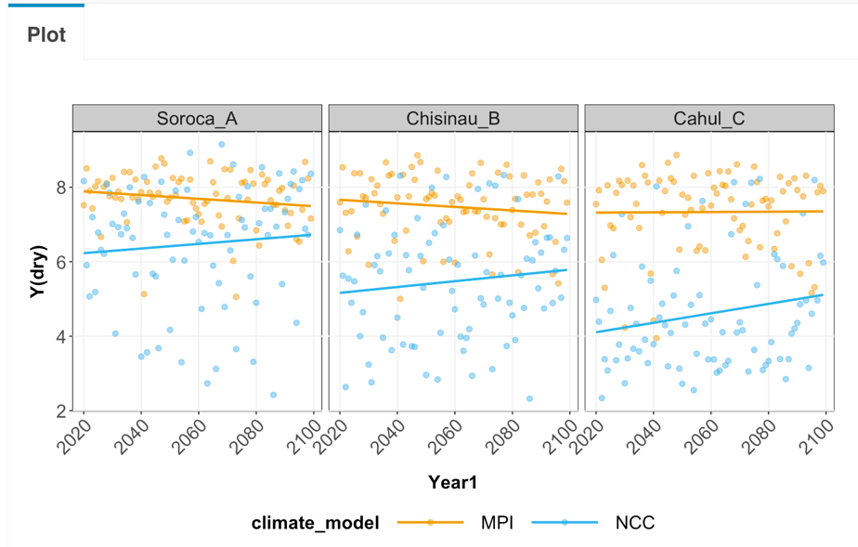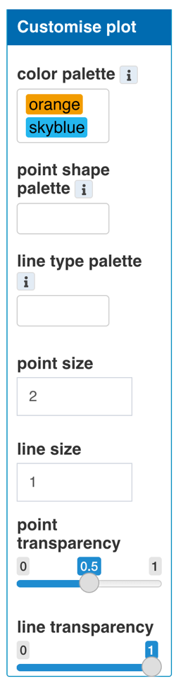

Next, Customise labels toolbox provide options to modify labels. For example, the Y and X axis labels can be changed to better explain what the variable is. Title of the plot can also be added. Type the new label in each box to update.

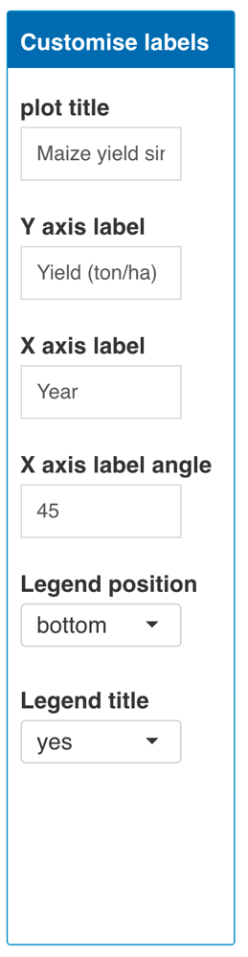

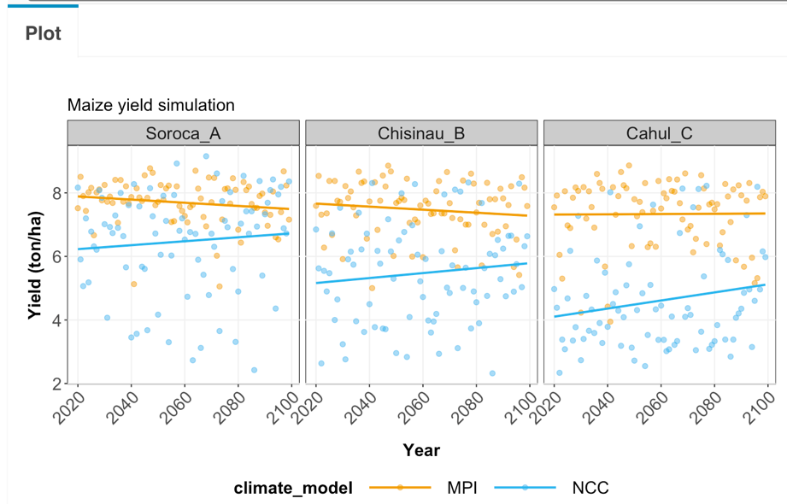

Next, Customise font size tool box provides options to change font size of different labels of the plot. Type in the font size in the box and the plot automatically updates.

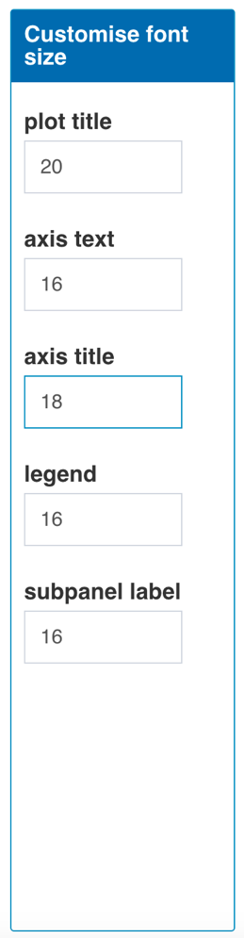

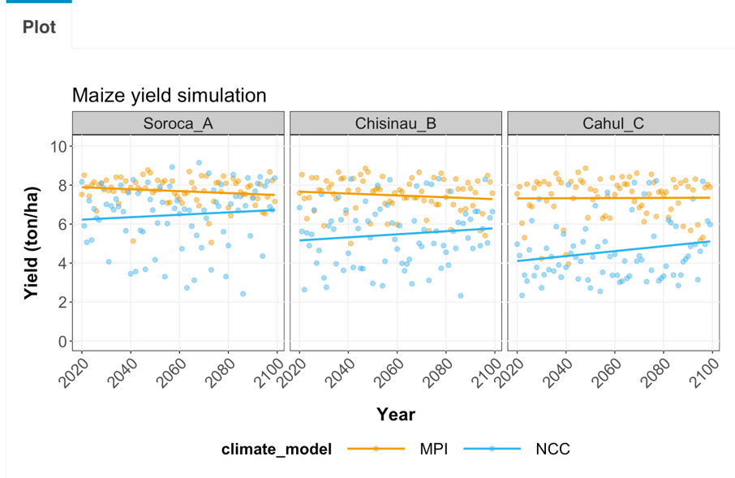

Next, Customise axis provide options to specify the range or limits of values to be displayed on each axis. Select the desired range and click Update button. By default, the app also tidy up the values of the tick mark labels automatically.

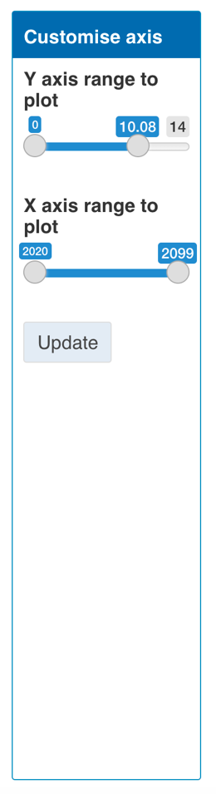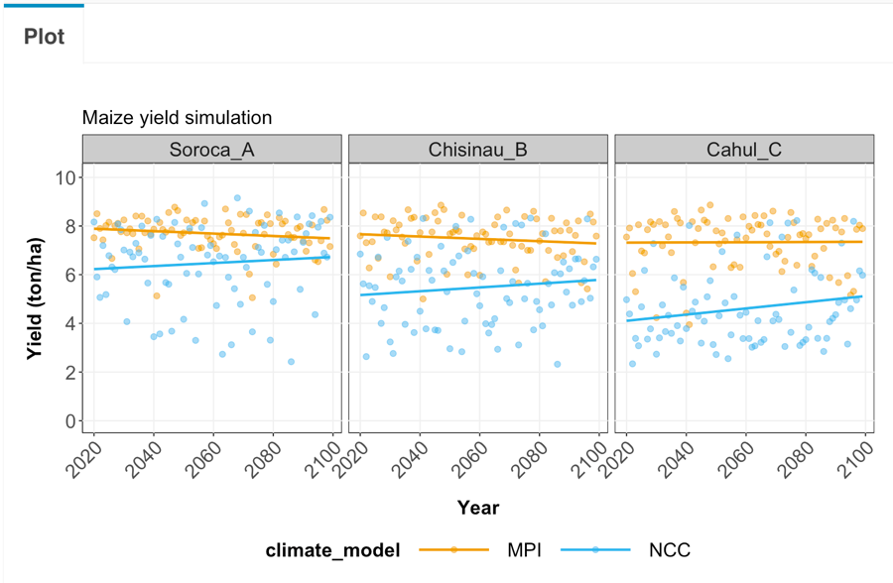

Next, the size of the plot can be specified. Desired Width and Height (in cm) of the plot can be typed into the box. These values are used to scale the plot both in the display inside the app and the finally exported plot. In this example, the dimension is changed so each subpanel looks squared and fit with the data and label size. To export the plot, select the desired format (png or pdf) then click the download button.

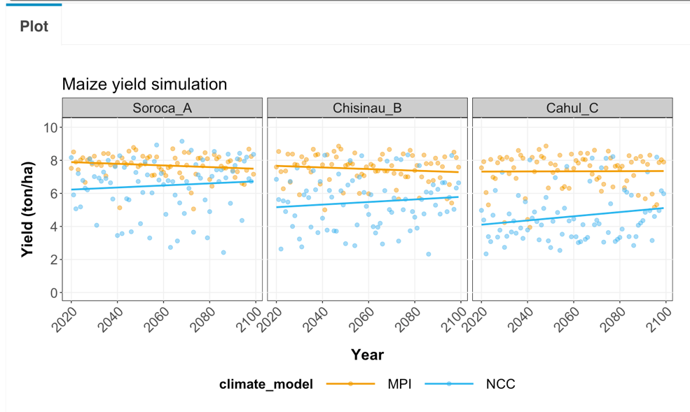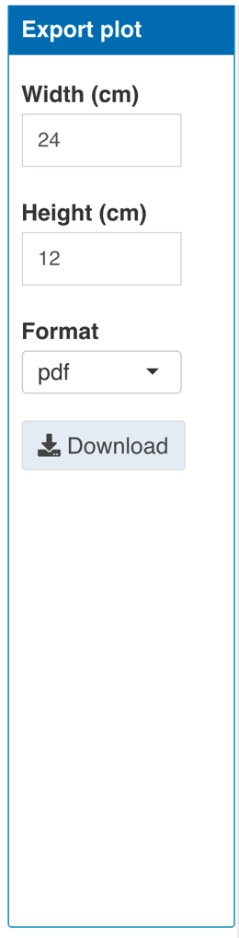

**9.2.3.1 Boxplot**

Boxplot can be useful for comparing data from different categories. First select variable to plot on the Y and X axis. The Y axis variable is a numeric variable of interest to be plotted, while the X axis variable is a categorical variable used to group data points into different boxes. Once all required options are selected, click Plot button to produce the plot. For example, we can produce a plot below to see how yield on the Y axis (Y(dry)) are different in different locations. By default, the plot will use all data from the whole dataset.



It is often useful to show different subset or groups in the data to allow comparisons. Different grouping information can be depicted by boxes with different colors. Different groups can also be split into subpanels arranged by columns and rows, respectively. For example, we can display different climate_model in different colors and subpanels. This way we can compare the results from simulations based on different climate models.



In some cases, it is also useful to see the changes in the variable of interest over periods of time. The boxplots can be split into subpanels arranged in columns by different time horizons. To do this, first, select time.horizon as a variable to split into subpanels by, then select time horizon duration to be used to subset the data.



For some analyses, the emphasis is on the change a variable of interest compared to a reference period (e.g. historical period). To do this, first, select yes for the Plot relative values option, then select the reference period year range. The data displayed on the plot will be calculated as a percentage of change relative to the average from the selected reference period. The calculated relative data can also be downloaded with the Download relative data button.



Again, we can customise the plot like we have done with the scatter plot. Click Customise & export plot button above the plot to show the toolboxes.

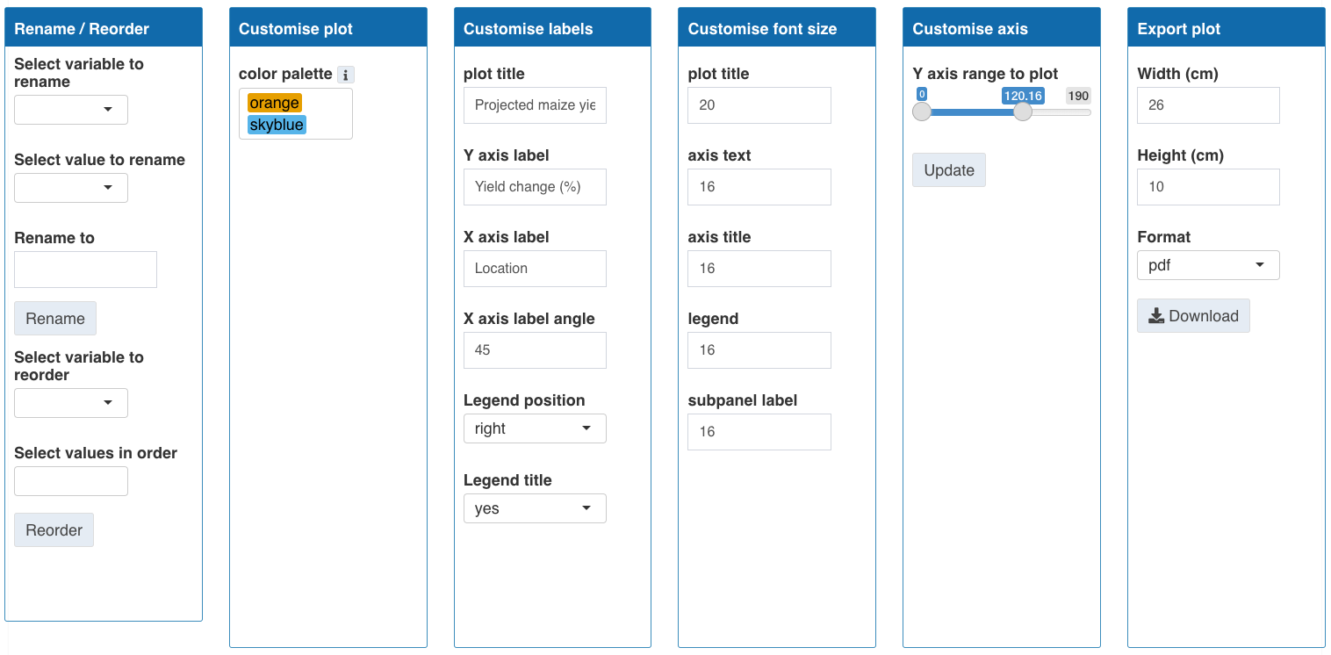

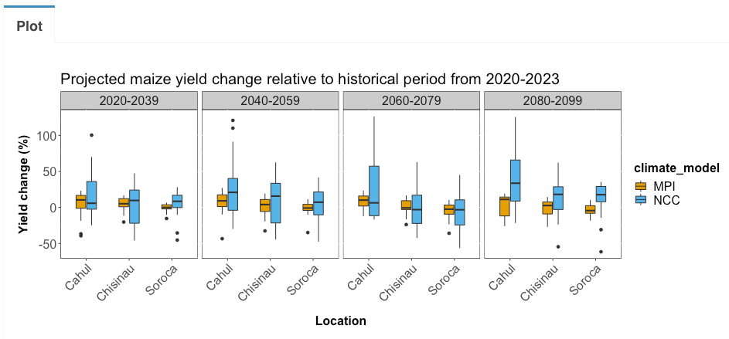

### 9.2.4 Analysis

After plotting to explore and visualise the data, we can conduct simple statistical analysis to support what we found from the plot.

**9.2.4.1 Time window summary**

From the boxplot above, we may want to have a number and summary statistics of yield across different time windows for each simulation. This can be done with the Time window summary option following 4 steps:

- select the year range to analyse. the whole dataset in this example.

- select time period window size (years). The data will be divided into subsets of the specified time window size. 20 years in this example.

- select the variable to calculate summary statistics for. yield in this example.

- select grouping variables to further specify groups in the data to allow comparisons. Location and climate model in this example.

The dataset is subdivided into groups by the specified time windows and grouping variables, then data in each group are used separately to calculate summary statistics. The results and their grouping variables are displayed in a table, which can also be downloaded.



**9.2.4.2 Regression**

When exploring the relationship between variables, regression analysis can be conducted to model the data. For example, when we explore the projection of yield over time, we might want to fit a regression model to test if there is a significant change in yield over time. This analysis function fit a simple linear regression model on the dataset following 4 steps:

- select data type. seasonal data in this example.

- select dependent (Y) variable. Yield in this example.

- select independent (X) variable. Year in this example.

- select grouping variables to further specify groups in the data to allow comparisons. Location and climate model in this example.

The selected dataset will be subdivided into groups by the grouping variables, then data in each group are used separately to fit a simple linear regression model and return model estimates. The results and their grouping variables are displayed in a table, which can also be downloaded. We can see from the results that the yield does not correlate well with the time, or in other words, the yield does not change significantly over time, consistent with the plot we made earlier.



